Check Processing A/C/R Instruction Sheet
Updated November 2018

Submitting a Request

- Download/Open the Check Processing A/C/R Request Form

- Fill out ALL required fields (*) in addition to the appropriate correction field (varies per request type). Please fill out all required fields completely and correctly to allow for prompt processing of your request.
- Verify the IRN is the correct and complete IRN.
- The Request Type field is asking for the type of correction, not the type of the original deposit. Debits and credits are issued in relation to the Federal Agency, not the Financial Institution.
- Enter Corrected information only into the field appropriate for your request. Please do not enter information into the other Corrected fields.
  - If you submit a request for an Unauthorized Transaction or Return/Reverse Item, you do not need to enter information in the Corrected fields.
  - When requesting a Corrected Dollar amount, please use the whole amount for the original transaction and the whole amount for the corrected amount, not the difference.
    - Ex: A correction from $1000 to $100 uses $1000 in the original dollar amount and $100 in the corrected dollar amount, not the $900 difference.

- Select a correction Request Reason box. See an explanation of each below.

- Encoding Error – The dollar amount was entered incorrectly and needs to be changed.
- ACH Reversal – An item was processed as an ACH and needs to be returned.
- Stop Request – If an item is in the system as being represented and you wish to stop the re-presentment.
- Represent Photo-in-Lieu – The agency requests that an item be re-presented for payment.
- Reversal/Return Item – If an item has already been processed and you want to return it.
- Transaction Account Switch – A single item was processed for the incorrect ALC and needs to be transferred to the correct ALC.
- Account Switch (ALC Change) – Multiple items were processed for the incorrect ALC and need to be transferred to the correct ALC.
- Item Scanned Twice – An item has been scanned more than once and the duplicate(s) need to be debited.

Example:

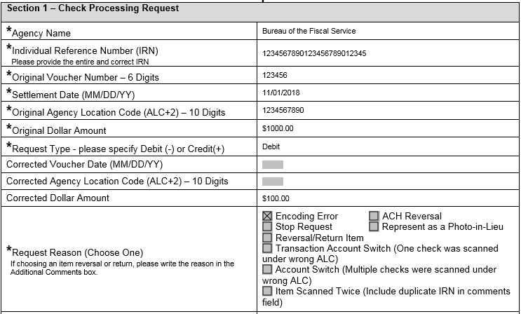

- This A/C/R will debit ALC+2 1234567890 for $1000.00 against Deposit Ticket Voucher 123456 to offset the deposit. Then it will credit ALC+2 1234567890 for $100.00 against Deposit Ticket Voucher 123456 to correct it.

- If, instead of choosing Encoding Error type, we choose Account Switch type and enter a Corrected ALC+2 of 1111111122, it will debit ALC+2 1234567890 for the $1000.00 in voucher 123456 to offset the original deposit. Then it will credit ALC+2 1111111122 for the $1000.00 in voucher 123456 to correct it.

- Fill in additional comments if needed.
- Fill in the approving official information.
- If original transaction WAS NOT processed through OTCnet (i.e. CashLink), attach the ORIGINAL transaction documentation to the email.
- Email to FiscalService.OTCChannel@citi.com

If steps are missed, information is invalid, or all required fields are not completed correctly, the request will be rejected and a new form will need to be submitted as a brand new request.

Following up on a Request

Call or email the OTCnet Customer Support Team with the case number that was provided in the response email. (Example case number: S-12345-12345). The OTCnet Customer Support Team will then locate the request and provide the most up to date information regarding that case.

Request Completed

An OTCnet Customer Support Team member will send an email when the request has been completed. How long the process takes to complete depends on the type of request. If you have a question on the status of a request, please contact the OTCnet Customer Support Team.

Sample Forms

See below for an example of a completed Check A/C/R Request form. Please note that this is just a sample form. When filling out an A/C/R form, please note that some fields require a specific amount of digits.

If assistance is needed filling out the forms, or if you have any questions or concerns, please contact the OTCnet Customer Support Team at 866.945.7920 or via email at FiscalService.OTCChannel@citi.com.

Sincerely,

OTC Customer Support Team
Toll free phone: 866-945-7920
DSN phone: 510-428-6824, Options 1, 3, 4
Email: FiscalService.OTCChannel@citi.com

Check Processing - OTCnet Adjustment, Correction or Rescission (A/C/R) Request Form
Instructions: Please fill in all required fields (*) in addition to the correction fields that apply to the request.
Section 1 – Check Processing Request

*Agency Name | Bureau of the Fiscal Service
*Individual Reference Number (IRN)  Please provide the entire and correct IRN | 123456789012345678910
*Original Voucher Number – 6 Digits | 123456
*Settlement Date (MM/DD/YY) | 01/01/16
*Original Agency Location Code (ALC+2) – 10 Digits | 1111111101
*Original Dollar Amount | 105.00
*Request Type - please specify Debit (-) or Credit(+) | Credit
Corrected Voucher Date (MM/DD/YY)
Corrected Agency Location Code (ALC+2) – 10 Digits
Corrected Dollar Amount | 150.00
*Request Reason (Choose One)  If choosing an item reversal or return, please write the reason in the  Additional Comments box. | X Encoding Error ACH Reversal  Stop Request Represent as a Photo-in-Lieu Reversal/Return Item  Transaction Account Switch (One check was scanned under wrong ALC)  Account Switch (Multiple checks were scanned under wrong ALC)  Item Scanned Twice (Include duplicate IRN in comments field)
Additional Comments

Section 2 – Approving Official from Agency or Financial Institution

The below approving Official certifies that he/she is duly authorized to request OTCnet adjustments, corrections, or reversals on behalf of the agency or financial Institution. The Official also agrees to be responsible for the accuracy of the information provided.

The approving official from an agency must have an OTCnet role of Check Capture Supervisor for Check Processing.

*Name | John Smith | *Phone Number | 866-945-7920
*OTCnet Role | Check Capture Supervisor | *Date MM/DD/YY | 01/04/2016

Please submit this completed request form to the Treasury OTC Support Center - FiscalService.OTCChannel@citi.com
Note: This request form must be emailed by the Check Capture Supervisor for Check Processing for requests from agencies to the OTC Support Center. The request will not be processed without the proper approval. If the approving Official is unavailable to make the approval, the A/C/R request will not be processed until one becomes available.
Please contact OTC Support Center for additional assistance:
FiscalService.OTCChannel@citi.com or 1-866-945-7920

