Profile of the Economy
(Office of Macroeconomic Analysis)
February 13, 2025
Introduction
The U.S. economy continued to display solid growth in the final quarter of 2024, with real GDP increasing 2.3 percent, supported by strong private domestic demand. The slowdown relative to the third quarter’s 3.1 percent increase partly reflected the impacts of consecutive hurricanes in October as well as labor strikes. Labor markets largely returned to balance by the end of last year, and although the pace of job growth continued to moderate, real earnings growth remained positive and initial unemployment claims remained near historically low levels.

Inflationary pressures ticked up in the fourth quarter as well as early in 2025. In September 2024, the Federal Reserve’s preferred measure—the Personal Consumption Expenditure (PCE) price index—slowed to within a tenth of a percentage point of the 2 percent inflation target. As of December 2024, however, this metric had accelerated to 0.6 percentage points above the target. Household moods improved late last year, but early this year, have deteriorated somewhat. However, the small business optimism index passed an important milestone, remaining above the index’s 51-year average for three consecutive months through January 2025.

Economic Growth
Real GDP growth increased by 2.3 percent at an annual rate in the fourth quarter of 2024, according to the advance estimate, slowing from the third quarter’s 3.1 percent pace. Faster growth in private consumption drove a sizeable portion of the most recent quarter’s gain in real GDP, but residential investment and public expenditures also supported the expansion.

Decomposing GDP into smaller components can be helpful in explaining the economy’s performance. The four components we consider are: (1) private domestic final purchases (PDFP), the most persistent and stable component of output, consisting of personal consumption expenditures (PCE), BFI, and residential investment; (2) government consumption and investment; (3) net international purchases (U.S. exports less U.S. imports); and (4) intermediate demand (or the change in private inventories). Examined separately, each component delivers specific information about activity in various sectors that can also be useful in predicting the future path of growth.

The first component, PDFP, is particularly important to analyze: it measures the private sector’s capacity to drive self-sustaining growth and, therefore, may signal the direction of future economic performance. In the fourth quarter, real PDFP growth was 3.2 percent at an annual rate—or only 0.2 percentage points below the third-quarter pace—and accounted for 2.7 percentage points of total GDP growth.

Personal consumption of goods and services accelerated sharply to 4.2 percent at an annual rate in the fourth quarter, following strong growth of 3.7 percent in the third quarter. PCE made the largest contribution to GDP growth of any component (2.8 percentage points). Purchases of goods rose by 6.6 percent, up from the third quarter’s 5.6 percent pace, and reflecting a 12.1 percent surge in spending on durable goods. Growth of expenditures on services was 3.1 percent, 0.3 percentage points faster than the third quarter’s rate.

BFI declined by 2.2 percent at an annual rate in the fourth quarter, swinging from a 4.0 percent gain in the third quarter. Equipment investment fell by 7.8 percent, following growth of 10.8 percent in the third quarter. Investment in business structures, which had been robust between mid-2021 and mid-2024, declined for the second consecutive quarter, falling 1.1 percent, though less than the 5.0 percent plunge in the third quarter. Intellectual property products investment increased for the eighteenth consecutive quarter, growing by 2.6 percent in the fourth quarter.

Residential investment, the final component of PDFP, grew by 5.3 percent in the fourth quarter, following declines of 2.8 percent and 4.3 percent in the second and third quarters, respectively. The fourth quarter’s advance reflected a positive turn in growth of single-family structures as well as continued growth in the other structures category, which was boosted in part by a large gain in brokers’ commissions.

Of the other components of GDP, government spending made a positive contribution to fourth quarter growth, while the change in private inventories subtracted from growth and net international demand was relatively neutral. Public sector expenditures —with equal contributions rates between federal and state and local spending—added 0.4 percentage points to GDP growth, less than one-half the 0.9 percentage point addition to third quarter growth. The change in private net inventory investment posed the largest drag on real GDP growth, subtracting 0.9 percentage points in the fourth quarter, far more than the 0.2 percentage point subtraction from growth in the third quarter. The net export deficit was little changed in the fourth quarter, with exports and imports making offsetting contributions to growth; in the third quarter, this component had subtracted 0.4 percentage points from real GDP growth.

Growth of Real GDP
(Quarterly percent change at annual rate)
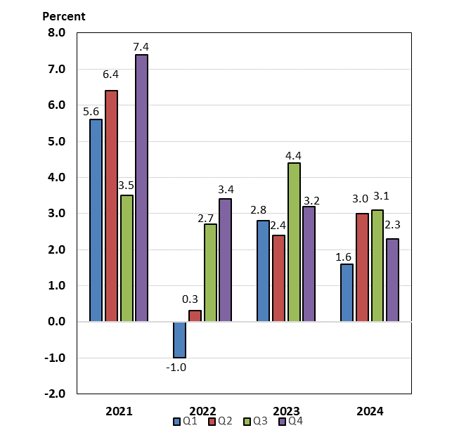

Labor Markets and Wages
Labor supply and demand in the economy largely returned to normal balance by the end of 2024. Payroll job growth has gradually slowed from the rapid rates that dominated 2021 and 2022—monthly average gains of roughly 600,000 and 375,000 jobs, respectively—to an average monthly gain of 204,000 jobs in the fourth quarter of 2024. The latest labor report for January 2025 showed payrolls increased by 143,000 over the month, in line with estimates of the break-even rates needed to maintain a steady unemployment rate given population growth.

The unemployment rate rose to a recent peak of 4.2 percent in July 2024, then hovered slightly above 4.0 percent in the second half of 2024, running 0.3 percentage points above the 2023 year-end rate.
In January 2025, the unemployment rate ticked down to 4.0 percent. A broader measure, which captures underemployment of the workforce, showed a similar pattern, rising from 7.2 percent at the end of 2023 to a peak of 7.8 percent in July and August 2024, before declining to end the year at 7.5 percent, where it remained as of January 2025. Both the unemployment and underemployment rates are still relatively low by historical standards. More timely data also suggest that unemployment remains low. As of the week ending February 8, the level of initial unemployment insurance claims had increased by about 7.5 percent from the end of December 2023, and as of the week ending February 1, continuing unemployment claims had drifted up by about 5.2 percent. These readings are only marginally above those in February 2020, just before the start of the COVID-19 pandemic in the United States.

The labor force participation rate (LFPR) was lower but stable during the fourth quarter, helping to maintain the supply of workers, and then ticked up in January. From October through December, the overall LFPR held steady at 62.5 percent, after holding at 62.7 percent throughout the third quarter. Prime-age (ages 25-54) worker participation continues to underpin overall participation: after reaching a 23-year high of 83.9 percent in July and August 2024, the prime-age LFPR drifted lower, standing at 83.4 percent at the end of the year, before ticking up to 82.5 percent in January 2025. Despite easing in the latter half of 2024, the prime-age LFPR rose 0.2 percentage points over the year and currently matches the rate in March 2020, at the start of the pandemic.

Along with the relatively resilient supply of labor, a moderation in labor demand has helped to restore balance in the labor market. The number of job openings (or vacancies) declined by roughly 15 percent over the year ending December 2024 (latest data available), extending a downward trend which began in March 2022. The ratio of job vacancies to unemployed workers also has gradually declined since the spring of 2022; as of December, there were 1.10 job openings per unemployed worker, down from the pandemic-related record high of 2.03 vacancies and slightly below the March 2020 peak of 1.24. The combination of stable labor supply at high levels (mainly due to elevated participation) and a more pronounced downtrend in job openings continues to foster a balancing of labor supply and demand.

Measures of wage growth in the private sector have been mixed. Growth in average hourly earnings was stable to slower during the first three quarters of 2024, before accelerating somewhat in the final quarter. Looking at quarterly averages of twelve-month growth rates, earnings growth slowed from 4.2 percent in the first quarter to 3.8 percent in the third quarter, before accelerating to 4.1 percent in the fourth quarter. Over the twelve months through January 2025, earnings growth was stable at 4.1 percent. These annual rates are considerably below the post-pandemic peak of 5.9 percent in March 2022, but higher than the 3.0 percent rate over 2019. Growth of earnings in real terms showed a strongly upward trend through much of 2024, with the twelve-month growth rate rising to 1.5 percent in September and October before stepping down to 1.0 percent over the year through January 2025. An alternative measure of wage growth, the Employment Cost Index (ECI), suggests that wage pressures continue to recede. (The ECI controls for employment shares among industries and occupations, making it a better reference for wage growth.) Over the four quarters through December 2024, the ECI for private sector wages and salaries grew 3.7 percent, slowing from 4.3 percent over the year earlier period. ECI growth has gradually slowed since reaching a near 40-year high of 5.7 percent in March 2022.

Payroll Employment
(Monthly average for year shown and monthly amounts, in thousands)
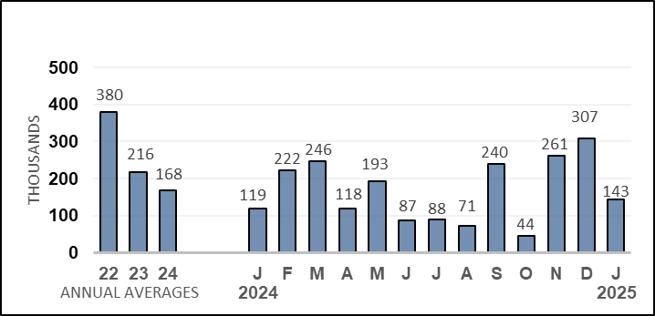

Unemployment Rate
(Percent)
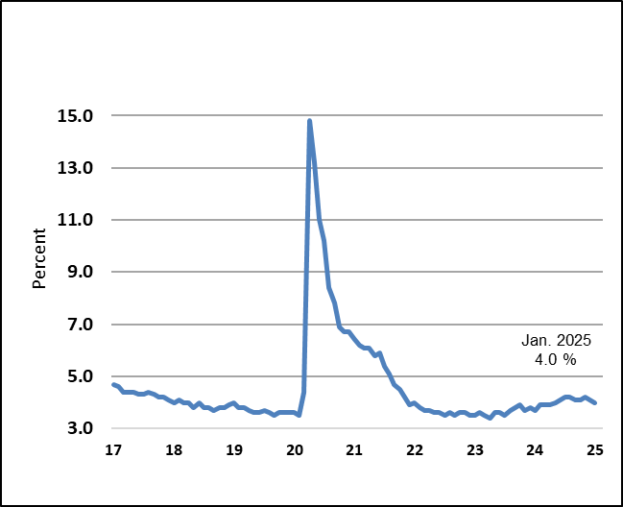

Prices
After peaking in June 2022 at 9.1 percent on a twelve-month basis, headline inflation as measured by the consumer price index (CPI) slowed significantly over the intervening years to 2.4 percent in September 2024, a 3½-year low. Since last fall, however, inflation has trended upward and was 3.0 percent over the twelve months through January 2025. On a monthly basis, inflation slowed last year to flat rates in May and June, then remained stable in a range of 0.1-0.2 percent through last October. Since then, however, monthly readings have increased; as of January 2025, the headline CPI rose 0.5 percent, or 5.7 percent annualized, the fastest monthly and yearly pace since August 2023.

Last year, energy price inflation was negative in the second and third quarters on an average monthly basis before turning positive in the final quarter, including a sharply higher 2.4 percent increase in December. Over the year through January 2025, energy price inflation was 1.0 percent, the fastest pace in six months. The uptrend reflects renewed concerns about geopolitical tensions and constraints on supply from Russia and Iran, among other factors.

Food price inflation was relatively stable earlier in 2024 before starting to pick up in the last quarter of the year, running at a monthly average of 0.2 percent in the second and third quarters and at 0.3 percent on the same basis in the final quarter, remaining close to rates observed prior to the pandemic. Although the rate of change in food prices has trended down, price levels for food remain higher than they were before the pandemic. In December 2024 and January 2025, monthly food price inflation was 0.3 percent and 0.4 percent, respectively. On a twelve-month basis, food price inflation had slowed to 2.1 percent through October 2024, less than one-third the peak rate in the autumn of 2022 and just above the pace of inflation seen before the pandemic. However, yearly food price inflation accelerated to 2.5 percent in December and January, the fastest paces in about one year.
Core inflation, which excludes energy and food, fluctuated on a monthly basis during 2024 in a range of 0.2 percent to 0.4 percent. In January 2025, core inflation was 0.4 percent. Core goods prices were on a declining trend between June 2023 and August 2024, but since then, have drifted up. In January 2025, core goods inflation was 0.3 percent, the fastest pace since May 2023, reflecting increases in inflation for durable as well as nondurable goods. On a twelve-month basis through January 2025, however, core goods prices were 0.1 percent lower.

Core services inflation remains the driving force behind core CPI readings. Monthly core services inflation averaged 0.4 percent over the first three quarters of 2024, but in the final quarter of the year, slowed to an average 0.3 percent per month. Inflation in this component accelerated to 0.5 percent in January 2025, however. Among core services, rent of housing services (rent of primary residential and owners’ equivalent rent, or OER) has the largest weight in the core CPI, and monthly inflation for this component that has largely hovered between 0.4 percent and 0.5 percent since May 2023. Significantly, rent of housing inflation slowed last year to an average 0.3 percent per month in the fourth quarter. Although these rates are still above those consistent with a 2.0 percent target rate for total inflation, they are well down from the 0.7 percent to 0.8 percent monthly rates seen in the latter half of 2022. Over the year through January 2025, rent of housing inflation was 4.5 percent, the slowest rate since March 2022. Over the three years before the pandemic, inflation for combined rent of primary resident and owners’ equivalent rent averaged 3.4 percent per year.

Inflation for non-housing core services has been an integral driver of elevated core inflation. In the third as well as fourth quarters, non-housing core services inflation was stable, averaging 0.3 percent growth per month, although this pace was faster than the average of 0.1 percent in the second quarter. The stable pace of core non-housing services inflation largely reflected a relative slowing in medical care price inflation as well as slower growth in prices for motor vehicle insurance and repairs. From 2017 to 2019, annual non-housing services inflation averaged 2.1 percent, versus 4.0 percent this last year. As of January 2025, core non-housing services inflation rose 0.8 percent—elevated in part by a resurgence in inflation for motor vehicle insurance. Over the past year, non-housing core services prices were up 4.0 percent.

Inflation as measured by the PCE price index is the Federal Reserve’s preferred measure of inflation: the FOMC’s 2 percent inflation target is expressed in terms of headline PCE, and core PCE inflation is also taken into consideration. There are notable differences in weights and methodologies between the CPI and the PCE measures. Historically, twelve-month CPI inflation has exceeded PCE inflation by about 0.4 percentage points on average. During 2024, however, the wedge widened, averaging 0.6 percentage points in the year’s first half. As OER slowed, the wedged narrowed noticeably, averaging 0.3 percentage points during the latter half. Headline PCE inflation slowed during 2024 and was 2.1 percent over the twelve months through September—or 0.1 percentage point above the FOMC inflation target—while core PCE inflation was 2.7 percent over that same period. Since then, inflation as measured by the PCE price index has accelerated: over the year through December 2024 (latest data available), headline PCE was 2.6 percent—0.6 percentage points above the Fed target percent—and the core reading was 2.8 percent.

Consumer Prices
(Percent change from a year earlier)
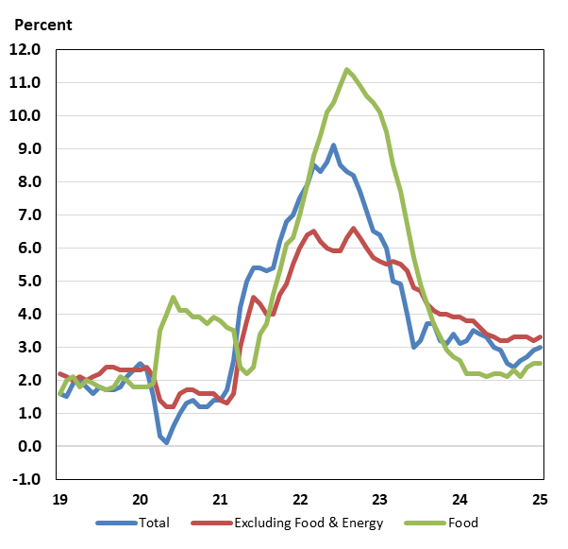

Housing Markets
After an overall slowing during the first half of 2024, housing activity remained mixed during the fourth quarter of 2024.

Net single-family planned and new construction, as measured by permits and starts, improved during the fourth quarter. Single-family permits increased an average of 0.4 percent per month, but single-family starts dropped 5.2 percent. However, planned as well as new home construction levels were lower on the year: over the twelve months through December 2024, single family permits were down 2.1 percent, while starts fell 2.6 percent.

Levels of planned and new construction for multi-family units (condominiums, co-ops, and apartment buildings) showed divergent trends over the fourth quarter. On average, permits increased 2.1 percent per month, after falling 3.2 percent per month during the previous quarter, suggesting a bottoming out in this segment of the market. But multi-family starts have declined at double-digit paces for six consecutive quarters, dropping 11.1 percent during the latest quarter. Over the year through December 2024, multi-family permits were down 5.3 percent, while starts dropped 8.4 percent.

Continuing construction activity declined at a slower pace in the fourth quarter. The total inventory of homes under construction ticked down by an average of 1.3 percent per month in the final quarter of 2024. Multi-family construction fell by 2.3 percent in the fourth quarter, offsetting a modest 0.2 percent decline in single-family building. Still, single-family construction grew 0.8 percent in December, the fastest monthly pace since March 2024. The total inventory of homes under construction fell during last year’s final quarter, standing at 1.431 million as of December 2024, well down from the record high of 1.711 million reached in October 2022 (data series begins in 1970). However, builder confidence, as measured by the National Association of Home Builder’s Housing Market Index, has turned up recently; after dropping to an eight-month low of 39 in August 2024, home builder sentiment has since trended higher, reaching 47 in January 2025.

Meanwhile, home sales remain near lows last seen in the aftermath of the global financial crisis. Existing home sales—which account for a supermajority of all home sales— declined in most months from August 2021 to September 2024, including an average drop of 0.6 percent per month in the third quarter of 2024. However, existing home sales rebounded solidly in the final quarter, rising an average 3.5 percent per month, and on the year through December, were 9.3 percent higher. Since mid-2022, by contrast, new single-family home sales have been roughly in line with sales levels during 2018 and 2019. Although above pre-pandemic readings, new home sales currently account for only about 15 percent of total home sales. New home sales rose an average 2.7 percent per month in the third quarter but fell an average 0.7 percent per month during the fourth quarter. The decline mainly reflected hurricane-related disruptions in October, with sales dropping 15.3 percent that month; subsequently, sales grew strongly in November and December and were up 6.7 percent over the year through December.

After showing solid improvement during the first half of 2024, inventories of existing homes rose further in the third quarter, then eased back in the fourth quarter—as is typical with that time of year. On an annual basis, inventories have risen recently but remain well below pre-pandemic levels. Months’ supply of existing homes for sale stood at 3.3 months in December, down from 4.3 months in September. The level of inventories remains historically low as current homeowners are locked into low, pandemic-era mortgage rates. The new home market does not suffer from the same lock-in effect, and inventories are well above pre-pandemic levels. Inventories of new homes on the market rose by an average 0.8 percent per month over 2024, and as of December were equivalent to 8.5 months of sales. Before the pandemic, a supply of roughly 6 months was typical for the new home market.

Movements of home price growth rates fluctuated on a month-to-month basis last year while twelve-month measures trended lower more consistently, but relative to peaks, home price growth has slowed considerably. The Case-Shiller 20-city house price index—which measures sales prices of existing homes—slowed last year, from an average 0.4 percent per month during the first half of the year to an average 0.3 percent per month in the latter half of 2024 through November (latest month available). Over the year ending November 2024, the 20-city index was up 4.3 percent, slower than the 5.6 percent, year-earlier advance (well down from the 21.3 percent twelve-month peak rate posted in April 2022). On the other hand, the FHFA purchase-only house price index showed accelerating price growth: on average, prices rose 0.3 percent per month during the first half of the year, but during the latter half through November (latest available), prices rose an average 0.4 percent per month. Nonetheless, over the year through November 2024, the FHFA measure was up 4.2 percent, slowing from the 6.9 percent pace over the year through November 2023 (and roughly one-fifth of the peak rate of 19.0 percent posted over the year through July 2021).

Consumer and Business Sentiment
Measures of business and consumer mood flagged earlier last year, then improved, on balance, by the close of 2024. Last year, the University of Michigan consumer sentiment survey implemented a change in methodology—a transition from phone interviews to a fully online survey—which can explain a significant share of the decline in Michigan Index of Consumer Sentiment over the first half of 2024. The survey transition was fully complete by July 2024, and the sentiment index then trended higher, reaching 74 in November. Since then, however, the index has declined and stood at 67.8 in early February 2025, roughly nine points below the year-earlier level. The latest survey registered broad-based declines in the current and expectations indices and also featured a 1.0 percentage point jump in the median year-ahead expected inflation rate to 4.3 percent—the largest monthly increase since October 2023. Respondents’ views about buying conditions for durables deteriorated noticeably.

The Conference Board’s alternative household sentiment survey has not had a similar methodological change, making interpretation of sentiment changes relative to earlier in 2024 simpler. The headline consumer confidence index has trended higher—albeit inconsistently—since spring 2024. After climbing to a 16-month high of 112.8 in November 2024, the index stepped down to 104.1 in January 2025, roughly seven points below the year-earlier level. Since spring 2024, the expectations component has largely driven the increase in the headline index, while the present situation index has been relatively flat. The consumer confidence index remains well above the January 2021 low of 87.1 but significantly lower than the June 2021 post-pandemic high of 128.9.

Turning to private firms, the National Federation of Independent Business’s (NFIB) small business optimism index rose sharply in November and December 2024, reaching 105.1 in December 2024, the highest level since 2018. Although the index eased to 102.8 in January 2025, it remained above the 51-year average of 98 for the third consecutive month. Results among component indices were mixed. After reaching a 19-month high in December, the net share of firms planning to increase employment declined only slightly in January. But the Uncertainty Index rose 14 points to 100 in January–the third highest recorded reading, after two months of decline.

Federal Budget Deficit and Debt
In FY 2024, the deficit increased $138 billion to $1.83 trillion (6.4% of GDP) as an increase in outlays more than offset rising receipts. Outlays rose by $617 billion to $6.75 trillion (23.4% of GDP) in FY 2024, partly reflecting increased net interest payments on the federal debt, a sharp drop in proprietary receipts by the Department of Education, and higher spending on Social Security and Medicare due to demographic aging. Meanwhile, total federal receipts jumped by $479 billion to $4.92 trillion (17.1% of GDP) in FY 2024. The rise in receipts was partly due to strong labor markets (which pushed up individual income tax withholdings and social insurance receipts), capital gains realizations, and the payment of some delayed taxes from FY 2023 (such as from households impacted by natural disasters).

In June 2023, the Treasury’s borrowing limit was suspended until early 2025. At the end of FY 2024, gross federal debt stood at $35.5 trillion, while debt held by the public was $28.3 trillion.

Monetary Policy
The Federal Open Markets Committee (FOMC) began raising its policy rate at its meeting in March 2022 to address inflationary pressures in the economy. From March 2022 to July 2023, the FOMC increased the short-term policy rate target range from 0.00-0.25 percent to 5.25–5.50 percent. More than a year later—at the meeting in September 2024—the Committee initiated the current monetary easing cycle with a cut of 50 basis points, followed by another cut of 25 basis points at the early-November meeting and an additional reduction of 25 basis points at the December meeting. At the January 28-29, 2025 meeting, the Committee maintained the target range at 4.25-4.5 percent.

In the statement accompanying the January meeting, the FOMC repeated the previous observation that “economic activity has continued to expand at a solid pace” but added in new language, noting that “[t]he unemployment rate has stabilized at a low level in recent months, and labor market conditions remain solid. The statement also repeated that “In considering the extent and timing of additional adjustments to the target range for the federal funds rate, the Committee will carefully assess incoming data, the evolving outlook, and the balance of risks.”

