Profile of the Economy

(Office of Macroeconomic Analysis)

May 13, 2025

**Introduction**

Although topline U.S. economic growth slowed considerably in the first quarter of 2025, private demand maintained the solid pace of growth registered in recent quarters. Real GDP growth declined 0.3 percent in the first quarter, primarily reflecting a very strong increase in import demand as well as a slowdown in federal spending. Private consumption and residential investment grew moderately, while private investment, especially in equipment, surged, and in addition, there was a very large build in private inventories. Demand for labor and the unemployment rate were both stable, while certain measures of labor force participation improved, such that labor market balance achieved by the end of last year remains in place, even though the pace of job growth continued to slow. Real earnings growth has been positive, and the overall unemployment rate, as well as initial unemployment claims, remain near historically low levels.

The pick-up in inflationary pressures, which began during the fourth quarter, continued over the turn of the year but has resumed a downward trend more recently. In September 2024, the Federal Reserve’s preferred measure—the Personal Consumption Expenditure (PCE) price index—had slowed to within a tenth of a percentage point of the 2 percent inflation target. By February 2025, this metric had accelerated to 0.7 percentage points above the target but as of March, the gap had narrowed to 0.3 percentage points. Household moods have deteriorated sharply thus far in 2025, reflecting uncertainty about tariff policy and the impact on inflation and employment. Meanwhile, the small business optimism index moderated from the recent peak in January, though it remains above the 2024 average monthly reading.

**Economic Growth**

Real GDP growth declined 0.3 percent at an annual rate in the first quarter of 2025, according to the advance estimate, after averaging nearly 3 percent during the final two quarters of 2024. However, the decline was mainly a function of a large swing in net exports, and other data show that economic growth, especially in the private sector, has remained solid so far this year.

Decomposing GDP into smaller components can be helpful in explaining the economy’s performance. The four components we consider are: (1) private domestic final purchases (PDFP), the most persistent and stable component of output, consisting of personal consumption expenditures (PCE), business fixed investment (BFI), and residential investment; (2) government consumption and investment; (3) net international purchases (U.S. exports less U.S. imports); and (4) intermediate demand (or the change in private inventories). Examined separately, each component delivers specific information about activity in various sectors that can also be useful in predicting the future path of growth.

The first component, PDFP (also called “core” GDP), is particularly important to analyze: it measures the private sector’s capacity to drive self-sustaining growth and, therefore, may signal the direction of future economic performance. In the first quarter, real PDFP growth was 3.0 percent at an annual rate—0.1 percentage point above the fourth-quarter pace—and added 2.6 percentage points to total GDP growth.

Personal consumption of goods and services slowed to 1.8 percent at an annual rate in the first quarter, contributing 1.2 percentage points to headline growth. This followed two quarters of very strong growth, including a 4.0 percent advance in the final quarter of 2024. Purchases of goods grew by 0.5 percent, slowing noticeably from the fourth quarter’s 6.2 percent pace, mainly reflecting a decline in durable goods spending of 3.4 percent, which followed a 12.4 percent surge in the final quarter of 2024. Spending on nondurables rose by 2.7 percent, a bit slower than the 3.1 percent increase in the previous quarter. Growth of expenditures on services was 2.4 percent, 0.6 percentage points slower than the fourth quarter’s rate.

BFI advanced 9.8 percent at an annual rate in the first quarter, swinging sharply from a 3.0 percent decline in the final quarter of 2024. The surge mainly reflected a 22.5 percent increase in equipment investment, which had declined by 8.7 percent in the fourth quarter, as capital expenditures on information processing equipment jumped by almost 70 percent, and spending on transportation equipment was up 13.2 percent, advances which were partly offset by lackluster growth or outright declines in other categories. Investment in business structures, which had been robust between 2022 and mid-2024, increased by 0.4 percent in the first quarter, following 2.9 percent growth in the previous quarter. After edging down 0.5 percent in the final quarter of 2024, intellectual property products investment increased 4.1 percent, posting growth for the eighteenth quarter of the past nineteen.

Residential investment grew by 1.3 percent in the first quarter, following a 5.5 percent advance in the previous quarter. The first quarter’s slower pace of growth reflected a much slower growth rate in the other structures category (includes brokers’ commissions from home sales), although there was continued strong growth in single-family structures, while the decline in multi-family structure investment tapered somewhat.

Of the other components of GDP, the change in private inventories, albeit a volatile component, made the largest contribution to first quarter growth, while government spending subtracted from growth and net international demand posed the largest drag on real GDP ever recorded. The change in private net inventory investment added 2.3 percentage points to growth, after subtracting 0.8 percentage points from growth in the fourth quarter. Growth in public sector expenditures subtracted 0.3 percentage points from real GDP after adding to growth in the final quarter of 2024. The decline mainly reflected a sharp downturn in federal spending on defense; state and local expenditures increased in the first quarter. The net export deficit subtracted a record 4.8 percentage points from growth in the first quarter, as exports added 0.2 percentage points to growth but imports subtracted 5.0 percentage points. In the fourth quarter, net exports added 0.3 percentage points to growth.

**Growth of Real GDP**

(Quarterly percent change at annual rate)

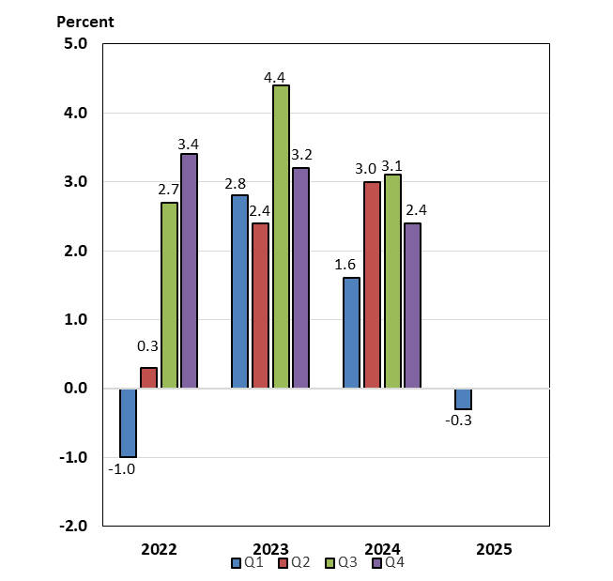

**Labor Markets and Wages**

Labor supply and demand in the economy largely returned to normal balance by the end of 2024 and have remained stable this year. Payroll job growth has gradually slowed from the rapid rates that dominated 2021 and 2022—monthly average gains of roughly 600,000 and 380,000 jobs, respectively—to an average monthly gain of 209,000 jobs in the fourth quarter of 2024, and then to 133,000 per month on average in this year’s first quarter. The latest labor report for April 2025 showed payrolls increased by 177,000 over the month, in line with estimates of the break-even rates needed to maintain a steady unemployment rate given population growth.

The unemployment rate has been remarkably stable for the past several months: since May 2024, it has hovered in the narrow range of 4.0 and 4.2 percent and stood at 4.2 percent as of April 2025. A broader measure, which captures underemployment of the workforce, declined during the latter half of 2024 to end the year at 7.5 percent, where it remained in January 2025. Since then, however, it has drifted up to a high of 8.0 percent in February, before declining to 7.8 percent in April, still 0.3 percentage points above the level at the end of last year. Even so, both the unemployment and underemployment rates are still relatively low by historical standards. More timely data also suggest that unemployment remains low. As of the week ending May 10, the level of initial unemployment insurance claims had increased only slightly from the end of December 2024, and as of the week ending May 3, the level of continuing unemployment claims was little changed over this timeframe. These readings are only marginally above those in February 2020, just before the start of the COVID-19 pandemic in the United States.

The labor force participation rate (LFPR) rose to an average 62.7 percent during last year’s third quarter, before declining to an average 62.5 percent during the fourth quarter and remaining at that rate during the first quarter of 2025. As of April, the LFPR had ticked up to 62.6 percent, continuing to signify a strong supply of labor. Prime-age (ages 25-54) worker participation has underpinned overall participation: after reaching a 23-year high of 83.9 percent in July and August 2024, the prime-age LFPR drifted lower, standing at 83.4 percent at the end of the year. In 2025, the rate has trended higher, reaching 83.6 percent in April. This rate is 0.5 percentage points higher than the rate in February 2020, just prior to the start of the pandemic.

Along with the relatively resilient supply of labor, a moderation in labor demand has helped to restore balance in the labor market. The number of job openings (or vacancies) declined by roughly 11 percent over the year ending March 2025 (latest data available), extending a downward trend which began in March 2022. The ratio of job vacancies to unemployed workers also has gradually declined since the spring of 2022; as of March 2025, there were 1.02 job openings per unemployed worker, down from the pandemic-related record high of 2.02 vacancies and well below the pre-pandemic peak of 1.24. The combination of stable labor supply at high levels (mainly due to elevated participation) and a more pronounced downtrend in job openings continues to foster a balancing of labor supply and demand.

Measures ofwage growth in the private sector have been mixed. Looking at quarterly averages of twelve-month growth rates, nominal average hourly earnings of all private sector employees grew by 4.1 percent per month during last year’s final quarter. Earnings growth then slowed to a monthly average of 3.9 percent in the first quarter of 2025, and over the twelve months through April, slowed further to 3.8 percent. These yearly rates are considerably below the post-pandemic peak of 5.9 percent in March 2022, but higher than the 3.0 percent rate over 2019. However, growth of earnings in real terms strengthened in mid-2024, peaking at 1.5 percent over the year through October 2024. After tapering through January 2025, real earnings growth picked up and reached 1.4 percent over the year through April 2025 – just under last fall’s peak. An alternative measure of wage growth, the Employment Cost Index (ECI), suggests that wage pressures continue to recede. (The ECI controls for employment shares among industries and occupations, making it a better reference for wage growth.) Over the four quarters through March 2025, the ECI for private sector wages and salaries grew 3.4 percent, slowing from 4.1 percent over the year earlier period. ECI growth has gradually slowed since reaching a near 40-year high of 5.5 percent in March 2022.

**Payroll Employment**

(Monthly average for year shown and monthly amounts, in thousands)

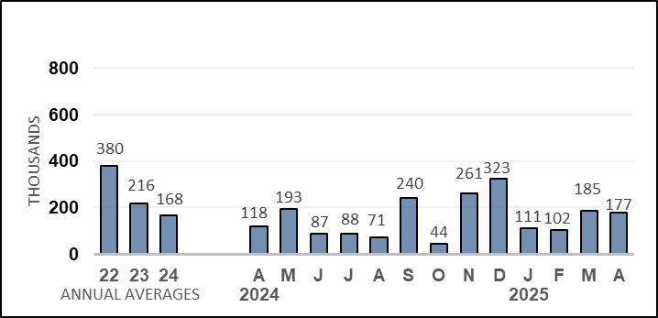

**Unemployment Rate**

(Percent)

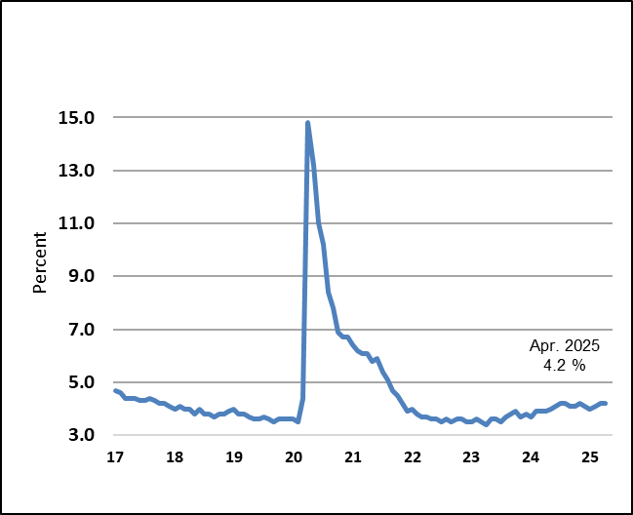

**Prices**

After peaking in June 2022 at 9.1 percent on a twelve-month basis, headline inflation as measured by the consumer price index (CPI) slowed significantly over the intervening years to 2.4 percent in September 2024, before rising to 3.0 percent over the year through January 2025. As of April 2025, however, twelve-month inflation had slowed to 2.3 percent, the lowest reading since February 2021. On a monthly basis, inflation slowed last year to flat rates in May and June, then remained stable in a range of 0.1‑0.2 percent through last October. After that, monthly inflation fluctuated in a higher range of 0.3-0.5 percent through January 2025, but by March, had slowed to a decline of 0.1 percent. For the month of April 2025, headline CPI was 0.2 percent.

Last year, energy price inflation was negative in the second and third quarters on an average monthly basis, but positive in the final quarter. During the first quarter of 2025, energy price inflation turned negative again, including a sharp 2.4 percent decline in March, but rose 0.7 percent in April. Over the year through April 2025, energy prices fell 3.7 percent, the slowest yearly pace since October 2024. The downtrend likely reflects policy uncertainty related to tariffs, concerns about the effect of tariffs on global growth and attendant demand for crude oil and rising global crude supplies—factors which have offset the effects of rising geopolitical tensions.

Food price inflation was relatively stable for five quarters between 2023 Q1 and 2024 Q3, running at a monthly average of 0.2 percent per quarter, close to rates observed prior to the pandemic. However, food price inflation picked up to an average 0.3 percent during the final quarter of 2024 and held steady at that pace in this year’s first quarter. In January and March 2025, monthly food price inflation accelerated to 0.4 percent. During the month of April, however, food price inflation was -0.1 percent, the first negative monthly reading since 2020. On a twelve-month basis, food price inflation had slowed to 2.1 percent through October 2024, less than one-third the peak rate in the autumn of 2022 and just above the pace of inflation seen before the pandemic. However, yearly food price inflation accelerated to 3.0 percent in March, the fastest pace in seventeen months, before tapering to 2.8 percent over the year through April. While the *rate of change* in food prices has steadied, price *levels* for food remain higher than they were before the pandemic.

Core inflation, which excludes energy and food, was 0.3 percent on an average monthly basis during the third and fourth quarters of 2024, then slowed to an average 0.2 percent per month during the first quarter of this year. In April, core inflation ticked up to 0.2 percent from 0.1 percent in March. Over the twelve months through April, core inflation remained at 2.8 percent, matching the yearly pace through March and marking the slowest rate in four years.

Core goods prices were on a declining trend between June 2023 and August 2024, then drifted higher thereafter. In April, core goods prices ticked up 0.1 percent, reflecting a 0.2 percent advance in durables prices, which was partially offset by a 0.1 percent decline in nondurables prices. On a twelve-month basis through April 2025, core goods prices were 0.1 percent higher, the first positive yearly reading since December 2023.

Core services inflation remains the driving force behind core CPI readings. Monthly core services inflation averaged 0.4 percent over the first three quarters of 2024, but in the final quarter of the year, slowed to an average 0.3 percent per month, a pace that remained in the first quarter of 2025 and in the month of April. Among core services, rent of housing services (rent of primary residential and owners’ equivalent rent, or OER) has the largest weight in the core CPI, and monthly inflation for this component largely hovered between 0.4 percent and 0.5 percent between May 2023 and November 2024. However, rent of housing inflation slowed to an average 0.3 percent per month in the fourth quarter, where it remained in the first quarter of 2025, before ticking up to 0.4 percent in the month of April. Although these rates are still above those consistent with a 2.0 percent target rate for total inflation, they are well down from the 0.7 percent to 0.8 percent monthly rates seen in the latter half of 2022. Over the year through April 2025, rent of housing inflation was 4.2 percent, the slowest pace since January 2022.

Inflation for non-housing core services has been an integral driver of elevated core inflation. Significantly, inflation in this metric slowed to 0.2 percent during the first quarter of 2025, from an average 0.3 percent during the latter half of 2024. The slowing pace of core non-housing services inflation largely reflected an easing of prices in several categories, including transportation services and hotel lodgings. From 2017 to 2019, annual non-housing services inflation averaged 2.1 percent, versus 4.0 percent over the year ending in December 2024. As of April 2025, core non-housing services inflation was 0.2 percent, and over the year through April, was 2.8 percent, the slowest twelve-month pace since March 2021.

Inflation as measured by the PCE price index is the Federal Reserve’s preferred measure of inflation: the FOMC’s 2 percent inflation target is expressed in terms of headline PCE, and core PCE inflation is also taken into consideration. There are notable differences in weights and methodologies between the CPI and the PCE measures. Historically, twelve-month CPI inflation has exceeded PCE inflation by about 0.4 percentage points on average. During 2024, however, the wedge widened, averaging 0.6 percentage points in the year’s first half. As core services price growth slowed, the wedge narrowed noticeably, averaging 0.3 percentage points during the latter half. Headline PCE inflation slowed during 2024 and was 2.1 percent over the twelve months through September—or 0.1 percentage point above the FOMC inflation target—while core PCE inflation was 2.7 percent over that same period. By February 2025, headline PCE inflation had accelerated to 0.7 percentage points above the target. Over the year through March 2025 (latest data available), headline PCE was 2.3 percent—0.3 percentage points above the Fed target percent—and the core reading was 2.6 percent.

**Consumer Prices**

(Percent change from a year earlier)

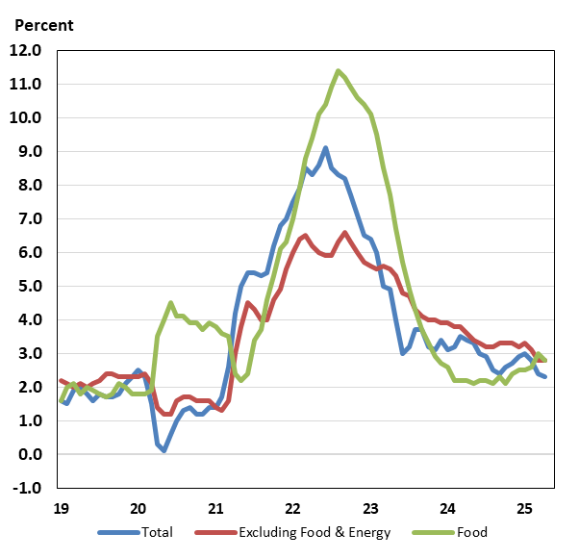

**Housing Markets**

Housing activity was mixed during the first quarter, with the single-family sector softening somewhat, while the multi-family sector showed signs of stabilization. Meanwhile, overall home sales remained muted.

Net single-family planned and new construction, as measured by permits and starts, both weakened during the first quarter. Single-family permits declined at an average 0.6 percent per month during the first quarter, after rising at an average rate of 0.9 percent per month during the final quarter of 2024. New single-family starts dropped at an average of 3.7 percent per month during the first quarter, following a 1.4 percent average monthly gain in the prior quarter. Planned as well as new home construction levels were lower on the year: over the twelve months through March 2025, single family permits were down 1.4 percent, while starts fell 9.4 percent.

Levels of planned and new construction for multi-family units (condominiums, co-ops, and apartment buildings) improved markedly during the first quarter, after diverging in recent quarters. On average, permits increased 1.4 percent per month in the first quarter, after rising by 1.8 percent per month in the previous quarter, marking the first consecutive positive quarterly readings since 2021. However, starts declined by an average 2.8 percent per month in the first quarter, after jumping 17.8 percent in the prior quarter. Over the year through March 2025, multi-family permits were up 3.9 percent, while starts jumped 46.8 percent.

Continuing construction activity slowed further in the first quarter. Over the first quarter, total construction fell by 2.5 percent, reflecting a 3.8 percent decline in multi-family construction as well as a 1.4 percent retreat in single-family building. At 1.391 million as of March 2025, the total number of units under construction was well down from the record high of 1.715 million reached in October 2022 (data series begins in 1970) but still above the 2019 average of 1.148 million.  Home builder confidence, as measured by the National Association of Home Builder’s Housing Market Index, dropped to an eight-month low of 39 in August 2024, then trended higher, reaching 47 in January 2025. However, the index fell sharply thereafter and stood at 40 in April.

Home sales have improved somewhat in recent quarters but remain near lows last seen in the aftermath of the global financial crisis.  Existing home sales—which account for a supermajority of all home sales— declined in most months from August 2021 to September 2024 but rose by an average 3.2 percent per month in the final quarter of 2024 and were 9.7 percent higher over the year through December 2024. The downward trend resumed this year, however as sales fell by an average 2.0 percent in the first quarter and were 2.4 percent lower over the year through March 2025. Since mid-2022, by contrast, new single-family home sales have been roughly in line with sales levels during 2018 and 2019. Although above pre-pandemic readings, new home sales currently account for only about 15 percent of total home sales.  Sales in this category rose by an average 0.4 percent per month in the first quarter, marking the third consecutive quarter of growth, after increasing by an average 2.7 percent and 0.3 percent per month in last year’s third and fourth quarters, respectively. New home sales were up 6.0 percent over the year through March 2025.

Inventories of existing homes for sale increased over the first three quarters of 2024, standing at 4.2 months in September, then eased to 3.8 months in December – easing is a typical pattern late in the year. On an annual basis, inventories have trended up, approaching pre-pandemic levels. Months’ supply of existing homes for sale stood at 4.0 months in March 2025, up from 3.2 months a year earlier. Even so, the level of inventories remains historically low as current homeowners are locked into low, pandemic-era mortgage rates. The new home market does not suffer from the same lock-in effect, and inventories are well above pre-pandemic levels. Inventories of new homes on the market rose by an average 0.7 percent per month over 2024 and ended the year at 8.2 months of sales. During the first quarter of 2025, the pace of growth increased by an average 0.9 percent per month, and inventories stood at 8.3 months of sales as of March. Before the pandemic, a supply of roughly 6 months was typical for the new home market.

Movements of home price growth rates fluctuated on a month-to-month basis last year and early this year, but twelve-month measures have slowed more consistently. Relative to peak rates, however, home price growth has slowed considerably to paces below pre-pandemic era rates. The Case-Shiller 20-city house price index—which measures sales prices of existing homes—was relatively stable last year, increasing by an average 0.4 percent per month during the first as well as the second halves of the year. During January and February of this year (latest months available) prices also rose at an average 0.4 percent per month. Over the year through February 2025, the 20-city index was up 4.5 percent, slower than the 7.5 percent, year-earlier advance (and less than one-quarter of the 21.3 percent twelve-month peak rate posted in April 2022).  The FHFA purchase-only house price index accelerated during the latter half of 2024 to an average 0.5 percent per month, up from an average 0.3 percent per month during the first half. However, this measure of house prices slowed again during the first two months of this year to an average of 0.2 percent per month. Over the year through February 2025, the FHFA measure was up 3.9 percent, slowing from the 7.3 percent pace over the year through February 2024 (and roughly one-fifth of the peak rate of 19.0 percent posted over the year through July 2021).

**Consumer and Business Sentiment**

Although measures of business and consumer mood improved, on balance, towards the end of 2024, they have declined thus far in 2025. Last year, the University of Michigan consumer sentiment survey’s transition to a fully online survey was completed in July 2024, facilitating comparisons only from that point forward. Between July and December 2024, the index trended higher, reaching 74.0. Since then, however, the index has declined and stood at 52.2 in late April 2025, 25 points below the year-earlier level and one of the lowest levels on record. The latest survey for April registered broad-based declines in the current and expectations indices and featured a jump of 1.5 percentage points in the median year-ahead expected inflation rate to 6.5 percent—the highest reading since 1981. Respondents’ views about buying conditions for durables fell to the lowest level since last November after surging in December and January.

The Conference Board’s alternative household sentiment survey has not had a similar methodological change, making interpretation of sentiment changes relative to prior periods simpler. The headline consumer confidence index trended higher—largely driven by gains in the expectations component—between spring 2024 until November, when it climbed to a 16-month high of 112.8. Since then, the index has fallen sharply, and in April, stood at 86.0, the lowest reading since the pandemic low in April 2020. Moreover, the consumer confidence index is now nearly 43 points lower than the June 2021 post-pandemic high of 128.9. Between spring 2024 and late 2024, the expectations component had largely driven previous gains in the headline index, while the present situation index had been relatively flat. More recently, both components have declined; in April, the Expectations Index dropped 12.5 points to 54.4, well below The Conference Board’s threshold level of 80, indicating that recession risk is elevated.

Turning to private firms, the National Federation of Independent Business’s (NFIB) small business optimism index rose sharply in November and December 2024, reaching 105.1 in December 2024, the highest level since 2018 and well above the 51-year average of 98.0. Thus far in 2025, however, the index has declined and stood at 95.4 in April – below the long-term average, but almost 3 points above the average in 2024.

**Federal Budget Deficit and Debt**

In FY 2024, which ended last September, the deficit widened by $138 billion to $1.83 trillion, equal to 6.4 percent of GDP as an increase in outlays more than offset rising receipts. Outlays rose by $617 billion to $6.75 trillion (23.4 percent of GDP) in FY 2024, partly reflecting increased net interest payments on the federal debt, a sharp drop in proprietary receipts by the Department of Education, and higher spending on Social Security and Medicare due to demographic aging. Meanwhile, total federal receipts jumped by $479 billion to $4.92 trillion (17.1 percent of GDP) in FY 2024. The rise in receipts was partly due to strong labor markets (which pushed up individual income tax withholdings and social insurance receipts), capital gains realizations, and the payment of some delayed taxes from FY 2023 (such as from households impacted by natural disasters). Between October 2024 and April 2025, the deficit was $1.0 trillion, or $194 billion higher than the comparable period in FY 2024. Federal receipts were 4.9 percent higher, while federal outlays were 8.9 percent higher than the first seven months of FY 2024.

The Treasury’s borrowing limit was reinstated on January 1, 2025. At the end of FY 2024, gross federal debt stood at $35.5 trillion, while debt held by the public was $28.3 trillion. As of the end of April 2025, gross federal debt stood at $36.2 trillion, while debt held by the public was $28.9 trillion.

**Monetary Policy**

At the September 2024 meeting of the Federal Open Markets Committee (FOMC), the Committee initiated the current monetary easing cycle with a cut of 50 basis points, followed by another cut of 25 basis points at the early-November meeting and an additional reduction of 25 basis points at the December meeting. At the January 28-29, March 18-19, and May 6-7, 2025 meetings, the Committee maintained the target range at 4.25-4.50 percent.

In the statement accompanying the May meeting, the FOMC observed that, “Although swings in net exports have affected the data, recent indicators suggest that economic activity has continued to expand at a solid pace. The unemployment rate has stabilized at a low level in recent months, and labor market conditions remain solid. Inflation remains somewhat elevated. The statement added that, “Uncertainty about the economy outlook has increased further” and noted that, “the risks of higher unemployment and higher inflation have risen.” The statement also repeated that “In considering the extent and timing of additional adjustments to the target range for the federal funds rate, the Committee will carefully assess incoming data, the evolving outlook, and the balance of risks.”