**Proposed Budgetary Accounts and Transactions**

**FY 25 Modifications**

**Account Title**: Allocations of Authority - Anticipated **Transfers** From Invested Balances - Current-Year

**Account Number**: 416500

**Normal Balance**: Debit

**Definition**: This account is used to record the amount of current-year budget authority anticipated by a receiving allocation Treasury Appropriation Fund Symbol (TAFS), based on an apportionment request by the receiving TAFS, to be distributed from the parent TAFS via non-expenditure transfer, during the fiscal year. Use this USSGL account in conjunction with USSGL accounts 416600, "Allocations of Realized Authority - To Be Transferred From Invested Balances - Current-Year," and/or 416700, "Allocations of Realized Authority - Transferred From Invested Balances - Current-Year." **Although the normal balance for this account is debit, it is acceptable in certain instances for the account to have a credit balance.**

**Justification:** Added clarifying language to the title and definition.

**Account Title:** Reinstated Undelivered Orders - Obligations, Unpaid

**Account Number:** 480110

**Normal Balance:** Credit

**Definition:** This account is used to reinstate the amount of goods and/or services ordered, which have not been actually or constructively received and for which amounts have not been prepaid or advanced. This USSGL account is only appliable to **grants and compact agreements recorded against** budget object class 41.

**Justification:** Definition was changed for clarity.

**Account Title:** Reinstated Delivered Orders - Obligations, Unpaid

**Account Number:** 490110

**Normal Balance:** Credit

**Definition:** This account is used to reinstate the amount accrued or due ~~for: (1) services performed by employees, contractors, vendors, carriers, grantees, lessors, and other government funds; (2) goods and tangible property received; and (3) programs for which no current service performance is required such as annuities, insurance claims, benefit payments, loans, etc~~. This USSGL account is only applicable to **grants and compact agreements recorded against** budget object class 41.

**Justification:** Definition was changed for clarity.

**Proposed Accounts Effective FY 26**

**Account Title:** Appropriations Derived from Future Trust Fund Receipts

**Account Number:** 439440

**Normal Balance:** Debit

**Definition:** This account is used to identify the amount of future Airport and Airway Trust Fund and Highway Trust Fund receipts where Department of Transportation trust fund appropriations to liquidate contract authority and appropriations have been enacted in excess of trust fund receipts collected to date. This account does not close at year-end.

**Justification:** This account is needed for a DOT anomaly.

**Affected TCs:** **A521 & A525** **(See Budgetary TC Additions and Revisions handout for details)**

**Account Title**: Reinstated Undelivered Orders - Obligations, Prepaid/Advanced

**Account Number**: 480210

**Normal Balance**: Credit

**Definition**: This account is used to reinstate the amount of goods and/or services ordered, which have not been actually or constructively received but have been prepaid or advanced.  This USSGL account is only appliable to grants and compact agreements recorded against budget object class 41.

**Justification:** This account will provide a mechanism for agencies to record a reinstated undelivered order that has been prepaid or advanced.

**Affected TCs: D115 & F337 (See Budgetary TC Additions and Revisions handout for details)**

**Account Title**: Downward Adjustments of Prior-Year Paid Delivered Orders - Obligations, Non-cash Refunds

**Account Number**: 497210

**Normal Balance**: Debit

**Definition**: This account is used to record the amount of non-cash refunds during the fiscal year resulting from downward adjustments to USSGL account 490200, "Delivered Orders - Obligations, Paid," with a budget object class 41 that were originally recorded in a prior fiscal year.

**Justification:**  This account will provide a mechanism for agencies to record a downward adjustment to a prior-year delivered order with a non-cash refund.

**Affected TCs: D115 (See Budgetary TC Additions and Revisions handout for details)**

**Proposed Account Revisions Effective FY 26**

**Account Title:** Receipts Unavailable for Obligation Upon Collection

**Account Number:** 439400

**Normal Balance:** Credit

**Definition:** This account is used to record the amount of **trust or special fund** receipts **(deposited in an “available” trust or special fund receipt account and recorded in USSGL account 411400)** that, immediately upon collection, is not available for obligation. These receipts, or a portion thereof, may be available for investment before becoming available for obligation. For example, the authorizing legislation may specify a portion of the receipts is available for obligation, while the entire amount of the receipts is available for investment. This account does not close at year-end.

**Justification:** Adding further clarification to the definition.

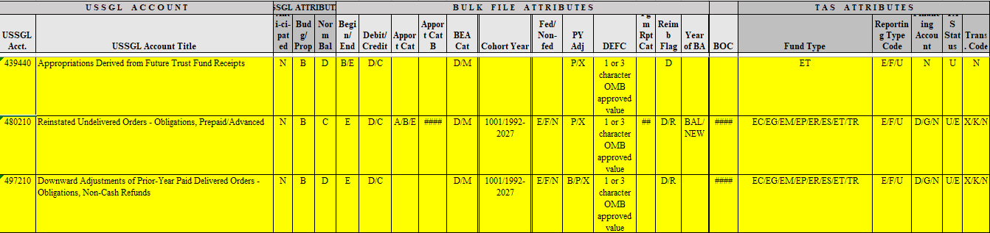

|  |  |  |  |  |  |  |  |  |  |
| --- | --- | --- | --- | --- | --- | --- | --- | --- | --- |
| **USSGL**  **Account** | **Balance**  **Sheet** | **Net**  **Cost** | **Net**  **Position** | **Custodial**  **Activity** | **Reclassified**  **Net Cost** | **Reclassified**  **Net**  **Position** | **SF133** | **Schedule P** | **SBR** |
| **439440**  **(FY 26)** | N/A | N/A | N/A | N/A | N/A | N/A | 1000,1020  1101,1201,  5311,5313,  5314 | 1000,1020  1101,1201,  5311,5313,  5314 | 1071,  1290 |
| **480210**  **(FY 26)** | N/A | N/A | N/A | N/A | N/A | N/A | 1048, 4030,  4033, 4120,  4123 | 1048, 4030,  4033, 4052,  4120, 4123, 4142 | 1071,  4190,  4220 |
| **497210**  **(FY 26)** | N/A | N/A | N/A | N/A | N/A | N/A | 1020, 1033,  1084, 1089, 4030, 4033, 4053, 4054, 4120, 4123, 4143, 4144 | 1020, 1033, 4030, 4033, 4052, 4053, 4120, 4123, 4142, 4143 | 1071,  4190,  4220 |