

Chapter 6. Reporting on Scanned Checks and Viewing Scheduled Reports
OTCnet Participant User Guide

Table of Contents
Overview, Topics, and Audience 1
Overview 1
Topics 1
Audience 2
Topic 1 Purpose of Accessing Check Processing Reports 3
Guidance for Handling OTCnet Reports Marked with Sensitive But Unclassified 4
Topic 2 View a CIRA Query 5
Item Status 6
View a CIRA Record 7
View a CIRA Record 8
Topic 3 Business Reports 15
CIRA CSV Report 16
CIRA CSV Report 18
Check Image Report 23
Check Image Report 24
Agency CIRA Report 26
Agency CIRA Report 27
LVD Contents Report 29
LVD Contents Report 30
Organization Hierarchy Report 32
Organization Hierarchy Report 33
215 Deposit Ticket Report 34
215 Deposit Ticket Report 35
5515 Debit Voucher Report 37
5515 Debit Voucher Report 38
ACR Activity Report 40
ACR Activity Report 41
Topic 4 Administration Reports 43
CIRA Transmission Summary Report 44
View CIRA Transmission Summary Report 45
CIRA Transmission (Detailed) Summary Report 47
CIRA Transmission Summary Report 48
View CIR Transmission Status for Check Processing 50
View CIR Transmission Status for Check Processing 51
Topic 5 Scheduled Reports 52
CIRA CSV Historical Report 53
CIRA CSV Historical Report 55
Previously Generated Reports 59
View Previously Generated Reports 60
Summary 61

List of Figures
Figure 1: Item Status Process Flow 6
Figure 2: CIRA Query Results Showing Count and IRN Table 12
Figure 3: CIRA Details Page 13
Figure 4: File Download Dialog Box: Open/Save or Download 21
Figure 5: Select Submit to View Check Image 25
Figure 6: Agency CIRA Report Parameters Page 27
Figure 7: LVD Contents Report Preview Page 31
Figure 8: Organization Hierarchy Report Preview Page 33
Figure 9: 215 Deposit Ticket Report Preview Page 36
Figure 10: 5515 Debit Voucher Report Preview Page 39
Figure 11: ACR Activity Report Preview Page 42
Figure 12: CIRA Transmission Summary Report Preview Page 46
Figure 13: CIRA Transmission (Detailed) Summary Report 49
Figure 14: CIR Transmission Status Export/Print Report Page 51
Figure 15: CIRA CSV- Request Successfully Submitted 58
Figure 16: View Previously Generated Reports 60

List of Tables
Table 1: Report Types and Descriptions 4
Table 2: Business Reports (1st column) and Access Type (1st row) 15
Table 3: Administration Reports (1st column) and Access Type (1st row) 43

Glossary
Select this link to access the full OTCnet Glossary.

Overview, Topics, and Audience

Overview
Welcome to Reporting on Scanned Checks. In this chapter, you will learn:
- The purpose of accessing check processing reports
- How to view a CIRA Query
- How to view and download a CIRA CSV Report
- How to view and print a Check Image Report
- How to view and print an Agency CIRA Report
- How to view and print a LVD Contents Report
- How to view and print an Organizational Hierarchy Report
- How to view and print a 215 Deposit Ticket Report
- How to view and print a 5515 Debit Voucher Report
- How to view and print an ACR Activity Report
- How to view and print a CIRA Transmission Summary Report
- How to view and print a CIRA Transmission (Detailed) Summary Report
- How to view CIR Transmission Status for Check Processing Report
- How to view and download Scheduled Reports

Topics
The topics in this chapter include the following:
- The purpose of accessing check processing reports
- CIRA Query
- Business Reports
- CIRA CSV Report
- Check Image Report
- Agency CIRA Report
- LVD Contents Report
- Organizational Hierarchy Report
- 215 Deposit Ticket Report
- 5515 Debit Voucher Report
- ACR Activity Report
- Administration Reports
- CIRA Transmission Summary Report
- CIRA Transmission (Detailed) Summary Report
- View CIR Transmission Status for Check Processing
- Scheduled Reports
- CIRA CSV Historical Report
- View Previously Generated Reports

Audience
The intended audience for the Reporting on Scanned Checks Participant User Guide includes:
- Agency Manager
- CIRA Viewer
- MVD Editor
- MVD Viewer
- FMS Viewer
- FMS Security
- View Reports

Topic 1 Purpose of Accessing Check Processing Reports
In this guide you will learn how to: run and print Check Processing reports, query using the View CIRA functionality, and query and download Scheduled reports. Based on your user role, you are authorized to 1) access one or more of the Check Processing reports, 2) view a CIRA record, and 3) view and download Scheduled reports available in OTCnet. The following roles are authorized to access reports:
- Agency Manager
- Check Capture Administrator
- MVD Editor/MVD Viewer
- FMS Viewer/FMS Security
- Report Viewer

The following are the reports a user may have access to view and download/print (see Table 1).
Table 1: Report Types and Descriptions
Business Report | Allows you to…
CIRA CSV | Export data based on a query to a comma separated value (CSV) report. The exported data can be used to import into other applications within an agency.
Check Image | View the front and back images of the checks for IRNs requested.
Agency CIRA | View the batch level transaction activity for a specified OTC Endpoint. A user can filter the report by Received Date, Capture Date, Batch ID, or Check Capture Operator.
LVD Contents | View the contents of a Local Verification Database (LVD) for a given OTC Endpoint.
Organization Hierarchy | View the structure of a Federal Program Agency as defined in OTCnet.
215 Deposit Ticket | View transaction information presented to a financial institution by a U.S. government agency with checks and other payment instruments to make a manual deposit. This report is auto generated for Check Capture. The report is searchable using a date range of up to 45 days. Data for the report is available for a duration of one year.
5515 Debit Voucher | View transaction information used to debit the Treasury General Account (TGA) to decrease the amount of a deposit made to that account. This report auto-generated for Check Capture. The report is searchable using a date range of up to 45 days. Data for the report is available for a duration of one year.
ACR Activity Report | View detailed information about transactions that were adjusted, corrected, or reversed/rescinded.

Administration Report | Allows you to…
CIRA Transmission Summary | View the list of transactions sent to Debit Gateway.
CIRA Transmission (Detailed) Summary | View the detailed information about transactions sent to Debit Gateway.
View CIR Transmission Status for Check Processing | View the status of CIR files that have been processed by CIR or are ready for CIR processing.

Guidance for Handling OTCnet Reports Marked with Sensitive But Unclassified
OTCnet users must safeguard reports generated from OTCnet that are marked as sensitive but unclassified (SBU) and only share these on a need-to-know basis. OTCnet reports marked as SBU must be safely destroyed (i.e., shredded or electronically deleted) when no longer needed.
Users must avoid transferring reports generated from OTCnet that are marked as SBU. If it is necessary to transfer an SBU OTCnet report, users must adhere to the “need-to-know” principle and perform the transfer in a secure fashion, encrypting the data before transferring it electronically and providing the encryption key to the recipient using a separate medium from the transfer method (e.g., by phone if the document is sent by email or by email if the document is sent using a secure transfer utility). The encryption algorithm used must be NIST-approved (e.g., AES-256).

Topic 2 View a CIRA Query
The Central Image and Research Archive (CIRA) is the image archive component of the OTCnet system from which authorized users are able to view transactions and images of all items processed. Users can perform searches and view groups of specific checks that have been archived. Access to the CIRA must be limited to authorized users due to the confidential nature of the items.
The CIRA contains an archive of all check images processed by participating agencies and locations. Once a batch has been approved, transactions are available for viewing shortly thereafter (volume and system activity affects the amount of time it takes to view the batch in CIRA).
As a CIRA Viewer, MVD Editor, MVD Viewer or FMS Viewer you are authorized to locate and view seven years of historical check data including check images and agency-entered information using the CIRA Query function. The CIRA provides batch level transaction activity for a specified OTC Endpoint.
You can filter by Received Date, Capture Date, Batch ID, or Check Capture Operator. Search for checks by OTC Endpoint, Individual Reference Number (IRN), first four User Defined Fields, Suspension Status and other search criteria. When running a search without specifying criteria other than the OTC Endpoint, the search results return all checks that your access will permit you to view.
Search Criteria Includes:
- OTC Endpoint
- Include Subordinates
- Retrieve Mobile Check Transactions Only
- Form Name
- Deploy Date
- User Defined Fields
- Account
- Bank Routing Number
- Item Reference Number (IRN)
- Check Number
- Check Amount
- Settlement Status
- 5515/ Debit Voucher Number
- 215/ Deposit Ticket Number
- Cashier ID
- Batch ID
- Received Date (filter)
- Capture Date (filter)
- Settlement Date (filter)
- Return Settlement Date (filter)

Item Status
In OTCnet, there is a status to indicate the current state of a transaction throughout the collection process (see Figure 1). Inquiries related to the status can aid with the research and troubleshooting of a particular transaction.
Figure 1: Item Status Process Flow
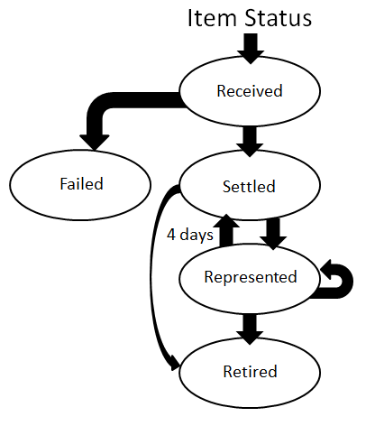
Received - The agency has sent this transaction through OTCnet. No settlement has been performed for this transaction yet.
Failed - The item was unable to be processed and/or settled by Treasury/Bureau of the Fiscal Service (BFS). These are items that could not be collected such as foreign items or possible duplicate items. These items are not included on your 215 Report.
Settled - This transaction is completed, and the funds have been credited to the agency’s CA$HLINK account. The effective date of the deposit and the 215 Deposit Ticket Report deposit ticket number are provided.
Represented - This transaction was returned with a reason code that allows for another collection attempt to be made. Depending on an agency’s policy, the item is reprocessed in an attempt to collect the funds from the check writer. Items with this status are in-process of collection.
Retired - This transaction was unable to be collected. The Agency receives a SF5515 Report Debit Voucher report with a debit processed to Debit Gateway, the effective date and debit voucher number is provided. The offset to the agency’s debit was an ACH return or a paper return (Check 21) received from the check writer’s financial institution. This transaction cannot be processed again through OTCnet.

View a CIRA Record
To view a CIRA record, from the CIRA Query, you will enter the search criteria for the report you would like to view, search for a transaction, search the ACR transaction. The CIRA Details page appears, presenting the Check Details, User Defined Fields, Check Image and Check History details or CIRA Details page showing ACR Transaction details.

View a CIRA Record
To view a CIRA record, complete the following steps:
- From the Check Processing tab select CIRA Query. The CIRA Query page appears.
- Enter your search criteria.
- Select an OTC Endpoint, required
Application Tip

If you do not know the full name of the OTC Endpoint, enter a partial name search (as few as one letter) in the Starts with text box and select the Select From List icon (magnifying glass). The configured OTC Endpoints appear according to the user’s access. Select the appropriate OTC Endpoint radio button.

- Check/uncheck the Include Subordinates check box
- Check/uncheck the Retrieve Mobile Check Transactions Only check box
- Select a Form Name
- Select a Deploy Date
Application Tips

- By default, the Include Subordinates check box is checked. Add a check mark to generate a report that contains data for the subordinate OTC Endpoints. Remove the check mark to generate a report that contains data only for the selected OTC Endpoint.
- By default, the Retrieve Mobile Check Transactions Only check box is unchecked. Data for Retrieve Mobile Check Transactions Only is not yet available and will be included in a future release.
- By default, the most recent Deploy Date and Form Version will populate the Deploy Date field, once the Form Name is selected.

- To search for a transaction:
  - Using the CIRA Query search criteria, complete the following steps:
- Under CIRA Query,
  - Select a Form Name
  - Select a Deploy Date
- Under User Defined Fields,
- Enter User Defined Field 1
- Enter User Defined Field 2
- Enter User Defined Field 3
- Enter User Defined Field 4
Application Tips

- By default, the CIRA Query screen is expanded. If the CIRA Query screen is expanded, the Search ACR Transaction screen is collapsed.
- By default, the most recent Deploy Date and Form Version will populate the Deploy Date field once the Form Name is selected.
- The User Defined Fields are visible based on the selected OTC Endpoint Form Name and Deploy Date.

- Enter the Account number
- Enter the Bank Routing Number
- Enter the IRN (Individual Record Number)
- Enter the Check Number
- Under Check Amount
- Select the appropriate drop-down field
- Enter the check amount
- Select a Settlement Status
- Enter the 5515/Debit Voucher Number
- Enter the 215/Deposit Ticket Number
Application Tips

- If an IRN or Batch ID and a date range (Received Date, Capture Date, Settlement Date, and Return Settlement Date) are entered, OTCnet ignores the date range.
- The 5515/Debit Voucher Number represents items returned to an agency due to unsuccessful collection efforts.
- The 215/Deposit Ticket Number represents items credited into FRB CA$HLINK for a given agency on a given day.

- Enter the Cashier ID
- Enter the Batch ID
- Select the Received Date: radio button
- Select From and To Received Date range
Or
- Select the On Received Date
Or
- Select the Check Capture Date: radio button
- Select From and To Check Capture Date range
Or
- Select the On Check Capture Date
Application Tips

- Received Date (From) and (To) represents the date range the check was received into OTCnet. Received Date (On) represents the single specific date the check was received into OTCnet.
- If the Received Date radio button is selected, OTCnet does not validate any other date range values (Capture Date, Settlement Date or Return Settlement Date).
- Check Capture Date (From) and (To) represents the date range the check was processed by the Check Capture Lead Operator or Check Capture Operator. Check Capture Date (On) represents the single specific end date the check was processed by the Check Capture Lead Operator or Check Capture Operator.
- If the Check Capture Date radio button is selected, OTCnet does not validate any other date range values (Received Date, Settlement Date or Return Settlement Date).

Or

- Select the Settlement Date: radio button
- Select From and To Settlement Date range
Or
- Select the On Settlement Date
Application Tips

- Settlement Date (From) and (To) represents the date range when the payment amount was debited from the check writer’s account. Settlement Date (On) represents the single specific date when the payment amount was debited from the check writer’s account.
- If the Settlement Date radio button is selected, OTCnet does not validate any other date range values (Received Date, Capture Date or Return Settlement Date).

Or

- Select the Return Settlement Date: radio button
- Select the From/On Date range
- Select the To Date range
Application Tips

- Return Settlement Date (From) and (To) represents the date range when the check item was returned. Return Settlement Date (On) represents the single specific date the check item was returned.
- When the Return Settlement Date radio button is selected, OTCnet does not validate any other date range values (Received Date, Capture Date or Settlement Date).
- By default, the CIRA Query screen is expanded. If the CIRA Query screen is expanded, the screen Search ACR Transaction collapsed.

Or
  - To query for an ACR transaction, complete the following steps:
- Select Search ACR Transaction to expand the screen
- Select an ACR Type
- Select an ACR Reason Code
- Enter an ACR Voucher Number
- Enter the From and To ACR Settlement range
Application Tips

- By default, the Search ACR Transaction screen is collapsed. If the Search ACR Transaction screen is expanded, the CIRA Query screen is collapsed.
- Search ACR Transaction options include All ACR, Adjustment, Correction, and Rescission.
- ACR Reason Code options include Duplicate Transaction Processed, Non-Cash Item, Transaction Amount Correction, Representment, Warranty Indemnity Claim, Voucher Date Change, Voucher Number Change, Account Switch, Transaction Account Switch, and ACH Reversal.
- The maximum numeric characters value for ACR Voucher Number is six.
- The maximum date range for the From and To ACR Settlement range is 90 days.

- Select Search to initiate the search.
- The Count table and Search Results table appears as shown in Figure 2. Select the IRN for the check details you would like to view.
Figure 2: CIRA Query Results Showing Count and IRN Table
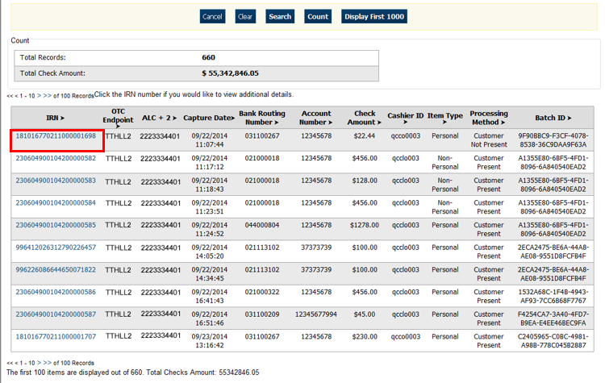

- The CIRA Details page appears showing the Check Details, User Defined Fields, Check Image and Check History details as shown in Figure 3.
Figure 3: CIRA Details Page
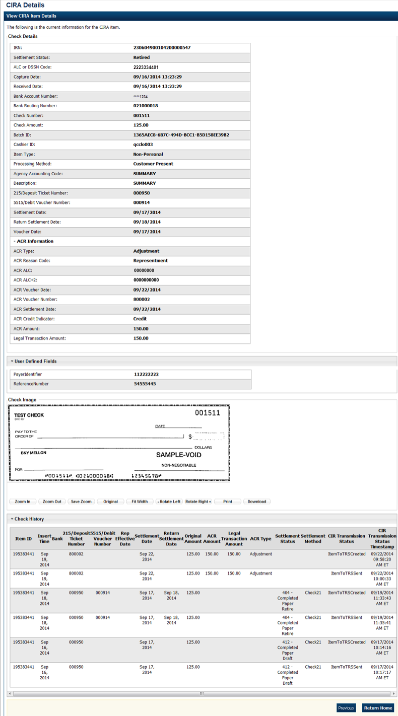
Application Tip

The CIRA Query details page is configured to display a maximum of 90 days of search results. This range parameter applies when a user searches using Received Date, Check Capture Date, Settlement Date, Return Settlement Date or ACR Settlement date. The system will display an error message if you search for results beyond the configured range.


Additional Buttons
- Select Cancel to return to the OTCnet Home Page. No data will be saved.
- Select Clear to clear all data fields and reset to the default selections.
- Select Count to display the total number of check transactions and the total check amount for the specified search criteria.
- Select Display First 1000 to retrieve the first 1000 records
- Select Verification Detail to view the corresponding MVD record for the check item. (Visible only if is a corresponding MVD record exists.)
Additional buttons exclusive to the View CIRA Item Details page:
- Select Zoom In to zoom in on the check image.
- Select Zoom Out to zoom out on the check image.
- Select Save Zoom to save the zoom percentage for the current session.
- Select Original to return the check image to the original display settings.
- Select Fit Width to fit the check image to the width of the open window.
- Select Rotate Left to rotate the check image counterclockwise 90 degrees.
- Select Rotate Right to rotate the check image clockwise 90 degrees.
- Select Print to the check image.
- Select Download to the check image.
- Select Previous to return to the previous page.
- Select Return Home to the OTCnet Home Page.

Topic 3 Business Reports
There are eight Business Reports that you may have access to, depending on your role. To print a report output, right select using your mouse and select Print.
Table 2: Business Reports (1st column) and Access Type (1st row)
Business Reports | Agency Manager | Check Capture Administrator | MVD Viewer | MVD  Editor | FMS  Viewer | View  Reports
CIRA CSV | X | X | X | X | X | blank
Check Image | X | X | X | X | X | X
Agency CIRA | X | X | X | X | X | X
LVD Contents | X | X | X | X | X | X
Organization Hierarchy | X | X | X | X | X | X
215 Deposit Ticket | X | X | X | X | X | X
5515 Debit Voucher | X | X | X | X | X | X
ACR Activity | X | X | X | X | X | X
Legend: Blank = N/A & X = Access

CIRA CSV Report
The CIRA CSV report is a business report that allows you to export data based on a query to a Comma Separated Value (CSV) report. The exported data can be used to import into other applications within an agency. From Check Processing Reports, select CIRA CSV Report. Enter the search criteria for the report you would like to view and search for a transaction and download the CSV file.
When selecting the Received Date radio button, consider the following information for the Received Date (From) and (To):
- If the Received Date radio button is selected, OTCnet does not validate any other date range values (Capture Date, Settlement Date or Return Settlement Date).
- Received Date (From) and (To) represents the date range the check was received into OTCnet. Received Date (On) represents the single specific date the check was received into OTCnet.
- If both the (From) and (To) Received Date are more than 18 months from the current date, an error message appears stating “Check transactions with a Received Date older than 18 months have been archived to the archive database according to the Fiscal Service data retention policy. These transactions are viewable through the CIRA CSV Report via Home>> Reports>> Scheduled Reports.” Any results that match the search parameters and have a Received Date older than 18 months from the current date are displayed.
- If the (From) or (To) Received Date is less than 18 months from the current date, the results that match the search parameters are displayed.
When selecting the Check Capture Date radio button, consider the following information for the Check Capture Date (From) and (To):
- If the Check Capture Date radio button is selected, OTCnet does not validate any other date range values (Received Date, Settlement Date, or Return Settlement Date).
- Check Capture Date (From) and (To) represents the date range
the check was processed by the Check Capture Lead Operator
or Check Capture Operator. Check Capture Date (On) represents the single specific end date the check was processed by the Check Capture Lead Operator or Check Capture Operator.
- If both the Check Capture Date (From) and (To) are more than 18 months from the current date, an error message appears stating “Check transactions with a Received Date older than 18 months have been archived to the archive database according to the Fiscal Service data retention policy. These transactions are viewable through the CIRA CSV Report via Home>> Reports>> Scheduled Reports.” Any results that match the search parameters and are with a Received Date older 18 months from the current date are displayed.
- If the (From) or (To) Check Capture Date is less than 18 months from the current date, the results that match the search parameters are displayed.

When selecting the Settlement Date radio button, consider the following information for the Settlement (From) and (To):
- If the Settlement Date radio button is selected, OTCnet does not validate any other date range values (Received Date, Capture Date or Return Settlement Date).
- If both the Settlement Date (From) and (To) are more than 18 months from the current date, an error message appears stating “Check transactions with a Received Date older than 18 months have been archived to the archive database according to the Fiscal Service data retention policy. These transactions are viewable through the CIRA CSV Report via Home>> Reports>> Scheduled Reports.” Any results that match the search parameters and are with a Received Date older 18 months from the current date are displayed.
- If the (From) or (To) Settlement Date is less than 18 months from the current date, the results that match the search parameters are displayed.
When selecting the Return Settlement Date radio button, consider the following information for the Return Settlement (From) and (To):
- If the Return Settlement Date radio button is selected, OTCnet does not validate any other date range values (Received Date, Capture Date or Settlement Date).
- If both the Return Settlement Date (From) and (To) are more than 18 months from the current date, an error message appears stating “Check transactions with a Received Date older than 18 months have been archived to the archive database according to the Fiscal Service data retention policy. These transactions are viewable through the CIRA CSV Historical Report via Home>> Reports>> Scheduled Reports.” Any results that match the search parameters and are with a Received Date older 18 months from the current date are displayed.
- If the (From) or (To) Return Settlement Date is less than 18 months from the current date, the results that match the search parameters are displayed.
To access the report, from Check Processing Reports, Business Reports, select Check Image Report.

CIRA CSV Report
To view a CIRA CSV report, complete the following steps:
- From the Reports tab, select Check Processing Reports. The View Check Processing Reports page appears.
- Under Business Reports, select CIRA CSV Report. The CIRA CSV Report page appears.
- Enter the search criteria for the report you would like to view.
- Select an OTC Endpoint, required
- Check/uncheck the Include Subordinates check box
- Check/uncheck Retrieve Mobile Check Transactions Only check box
Application Tips

- If you do not know the full name of OTC Endpoint, enter a partial name search (as few as one letter) in the Starts with text box and select the Select From List icon (magnifying glass). The configured OTC Endpoints appear according to the user’s access. Select the appropriate OTC Endpoint radio button.
- By default, the Include Subordinates check box is checked. Add a check mark to generate a report that contains data for the subordinate OTC Endpoints. Remove the check mark to generate a report that contains data only for the selected OTC Endpoint.
- By default, the Retrieve Mobile Check Transactions Only check box is unchecked. Data for Retrieve Mobile Check Transactions Only is not yet available and will be included in a future release.

- To search for a transaction:
  - Using the CIRA CSV Report search criteria, complete the following steps:
- Select a Form Name
- Select a Deploy Date
Application Tips

- By default, the CIRA CSV Report screen is expanded. If the CIRA CSV Historical Report screen is expanded, the CIRA CSV Report - ACR screen is collapsed.
- The Form Name is the name/list of available forms available for the selected OTC Endpoint. The Deploy Date is the date, time and version number of the selected form.
- By default, the most recent Deploy Date and Form Version will populate the Deploy Date field once the Form Name is selected.

- Under User Defined Fields,
  - Enter User Defined Field 1
  - Enter User Defined Field 2
  - Enter User Defined Field 3
  - Enter User Defined Field 4
- Enter the Account number
- Enter the Bank Routing Number
- Enter the IRN (Individual Record Number)
- Enter the Check Number
- Under Check Amount,
  - Select the appropriate drop-down field
  - Enter the check amount
    - Select a Settlement Status
    - Enter the 5515/Debit Voucher Number
    - Enter the 215/Deposit Ticket Number
Application Tips

- The User Defined Fields are visible based on the selected OTC Endpoint Form Name and Deploy Date.
- If an IRN or Batch ID and a date range (Received Date, Capture Date, Settlement Date, and Return Settlement Date) are entered, OTCnet ignores the date range.
- The 5515/Debit Voucher Number represents items returned to agency due to unsuccessful collection efforts.
- The 2515/Deposit Ticket Number represents items credited into FRB CA$HLINK for a given agency on a given day.

      - Enter the Cashier ID
      - Enter the Batch ID
      - Select the Received Date: radio button
      - Select From and To Received Date range
Or
      - Select the On Received Date

Or

- Select the Check Capture Date: radio button
- Select From and To Check Capture Date range
Or
- Select the On Check Capture Date

Or

- Select the Settlement Date: radio button
  - Select From and To Settlement Date range
Or
  - Select the On Settlement Date

Or

- Select the Return Settlement Date: radio button
  - Select the From/On Date range
  - Select the To Date range
  - To query for a CIRA CSV Report - ACR transaction, complete the following steps:
- Select Search ACR Transaction to expand the screen
- Select an ACR Type
- Select an ACR Reason Code
- Enter an ACR Voucher Number
- Enter the From and To ACR Settlement range, required
Application Tips

- By default, the Search ACR (Adjustment, Correction, and Rescission) Transaction screen is collapsed. If the Search ACR Transaction screen is expanded, the CIRA Query screen is collapsed.
- Search ACR Transaction options include All ACR, Adjustment, Correction, and Rescission.
- ACR Reason Code options include Duplicate Transaction Processed, Non-Cash Item, Transaction Amount Correction, Representment, Warranty Indemnity Claim, Voucher Date Change, Voucher Number Change, Account Switch, Transaction Account Switch, and ACH Reversal.
- The maximum numeric characters value for ACR Voucher Number is six.
- The From and To ACR Settlement fields are searchable for a duration up to 90 days. Additionally, the From and To ACR Settlement dates must be older than 18 months from the current date.

- Select Download CSV File. The File Download dialog box appears as shown in Figure 4.
Figure 4: File Download Dialog Box: Open/Save or Download
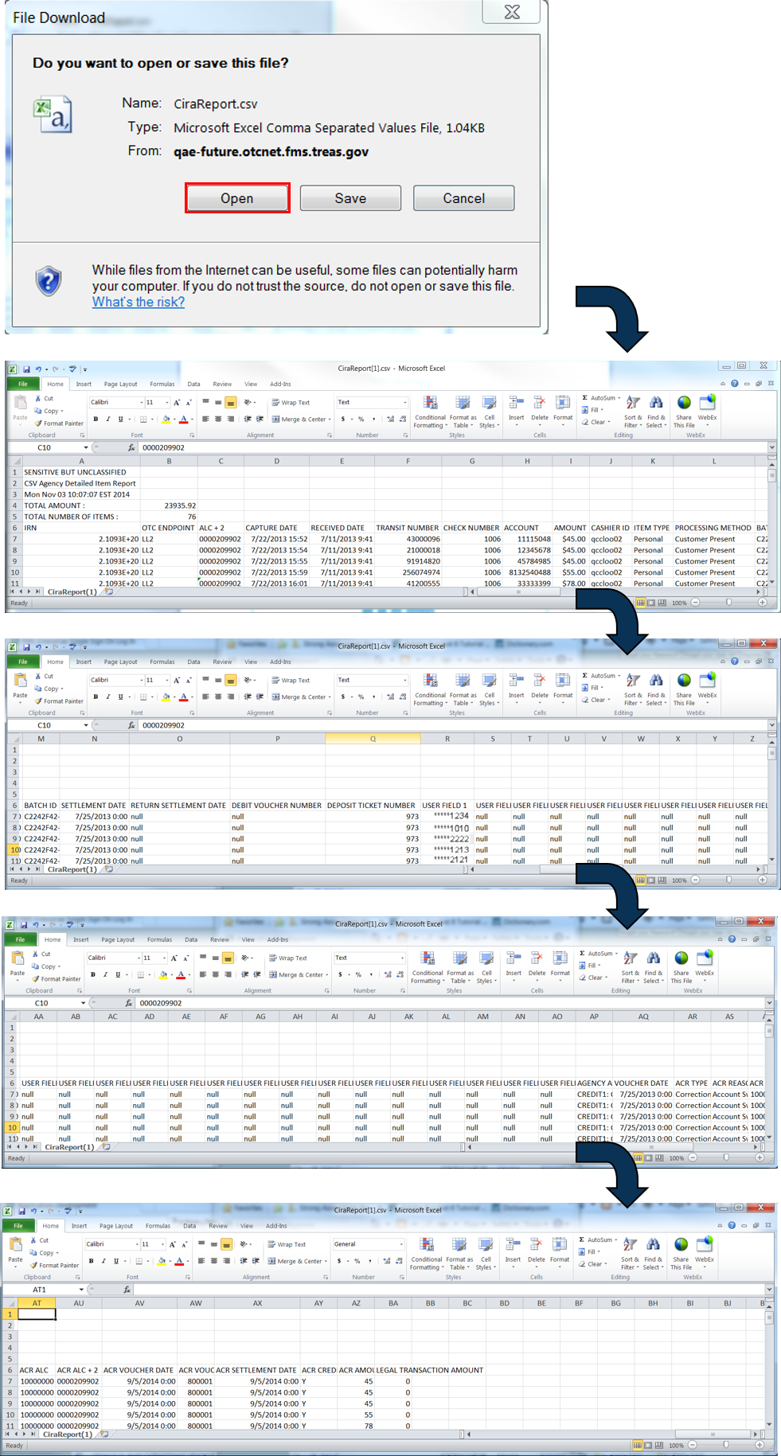
Application Tip

The CIRA CSV Report page is configured to download a maximum of 90 days of search results. This range parameter applies when a user searches using Received Date, Check Capture Date, Settlement Date, Return Settlement Date or ACR Settlement Date. The system will display an error message if you search for results beyond the configured range.

- Select Open or Save
Additional Buttons
- Select Cancel to return to the OTCnet Home Page. No data is saved.
- Select Clear to clear all data fields and reset to the default selections.
- Select Count to display the total number of check transactions and the total check amount for the specified search criteria.

Check Image Report
The Check Image Report allows you to view the front and back images of a check for an Individual Reference Number (IRN) that you request.
IRNs associated with a received date older than the minimum data retention period, as specified by Fiscal Service, may not be displayed on the report as these transactions are eligible to be deleted. As a result, this check image will no longer be accessible, and an error message will show stating that the IRN has not been found or has been deleted.
To access the report, from Check Processing Reports, Business Reports, select Check Image Report.

Check Image Report
To view a Check Image report, complete the following steps:
- From the Reports tab, select Check Processing Reports. The View Check Processing Reports page appears.
- Under Business Reports, select Check Image Report. The Check Image Report page appears.
- Enter the search criteria for the report you would like to view.
- Under Add IRNs to the list, enter the IRN(s) for the checks you would like to view.
Application Tips

- IRNs are between 20 and 32 alphanumeric characters in length and can contain the following characters:
  - The special characters of ', _, #, @, and -, surrounded by only alpha characters
  - The special characters of $ and |, surrounded by alphanumeric characters
- To enter multiple IRNs, separate each IRN by a space and/or comma.
- Check images for IRNs belonging to neutralized OTC Endpoints can be retrieved in the Check Image Report. These images can be retrieved by Agency Managers, Check Capture Administrators, View Reports, MVD Editors, or MVD Viewers who are provisioned to:
  - An OTC Endpoint level higher than the neutralized OTC Endpoint associated with the images
  - The highest-level OTC Endpoints associated with the images

- Select Add to IRN List.
- Under List of IRNs, check the check box(es) of the IRN(s) you would like to submit.
- Select Submit. Check image(s) appear on the same page as shown in Figure 5.
Figure 5: Select Submit to View Check Image
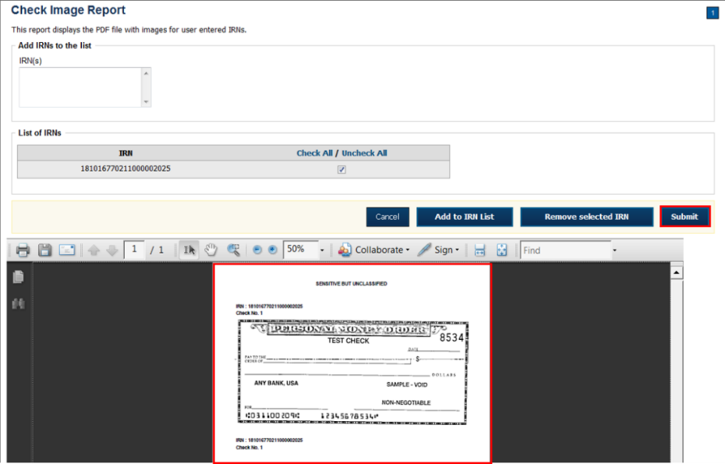
Additional Buttons
- Select Clear to clear all data fields and reset to the default selections.
- Select Cancel to return to the OTCnet Home Page. No data will be saved.

Agency CIRA Report
The Agency CIRA Report allows you to view the batch activity for specified OTC Endpoint and supplies, the sending OTC Endpoint receive date, item count and dollar amounts.
When selecting the Received Date radio button, consider the following information for the Received Date (From) and (To):
- If the Received Date radio button is selected, OTCnet does not validate any other date range values (Capture Date).
- (From) and (To) Received Date represents the date range the check was received into OTCnet.
- If both the (From) and (To) Received Date are more than 18 months from the current date, an error message appears stating “Check transactions with a Received Date older than 18 months have been archived to the archive database according to the Fiscal Service data retention policy. These transactions are viewable through the CIRA CSV Historical Report via Home>> Reports>> Scheduled Reports.” Any results that match the search parameters and have a Received Date older than 18 months from the current date are displayed.
- If the (From) or (To) Received Date is less than 18 months from the current date, the results that match the search parameters are displayed.
When selecting the Check Capture Date radio button, consider the following information for the Received Date (From) and (To):
- (From) and (To) Check Capture Date represents the date range the check was processed by the Check Capture Lead Operator or Check Capture Operator.
- If both the (From) and (To) Check Capture Date are more than 18 months from the current date, an error message appears stating “Check transactions with a Received Date older than 18 months have been archived to the archive database according to the Fiscal Service data retention policy. These transactions are viewable through the CIRA CSV Historical Report via Home>> Reports>> Scheduled Reports.” results that match the search parameters and have a Received Date older than 18 months from the current date are displayed.
To access the reports, from Check Processing Reports, Business Reports, select Agency CIRA Report Check Processing Reports.

Agency CIRA Report
To view an Agency CIRA report, complete the following steps:
- From the Reports tab, select Check Processing Reports. The View Check Processing Reports page appears.
- Under Business Reports, select Agency CIRA Report. The Agency CIRA Report parameters page appears as shown in Figure 6.
Figure 6: Agency CIRA Report Parameters Page
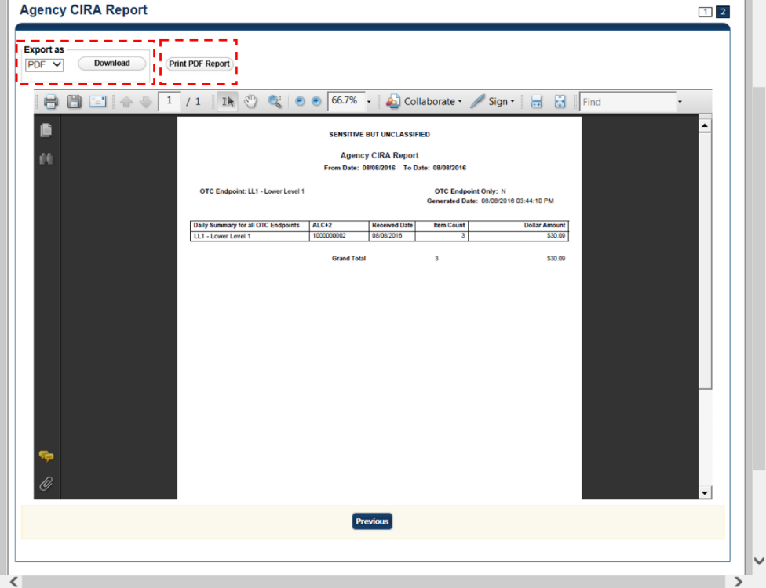
- Enter the search criteria for the report you would like to view.
Under Report Filters,
- Select the Date From date
- Select the Date To date
- Select Received Date or Captured Date
- Enter the Batch ID
- Enter the Cashier ID
- Select Yes or No to Include Subordinate OTC Endpoints
Application Tip

- Select Yes to generate a report that contains data for the selected OTC Endpoint as well as all of the lower-level OTC Endpoints.
- Select the No option to generate a report that contains data only for the selected OTC Endpoint.

- Select an OTC Endpoint to initiate the report. The Agency CIRA Report preview page appears.
Application Tip

CHK denotes a check capture OTC Endpoint; TGA denotes a deposit processing OTC Endpoint; M denotes a mapped accounting code; an open lock denotes access permission; and a closed lock denotes no access permission.

- Under Export as,
- Select a PDF, Excel or Word
- Select Download

Or

- Select Print PDF Report
Additional Button
- Select Previous to return to the previous page.

LVD Contents Report
The LVD Contents Report allows you to view the contents of a Local Verification Database (LVD) for a given OTC Endpoint. To access the report, from Check Processing Reports Business Reports, select LVD Contents Report.

LVD Contents Report
To view an LVD Contents report, complete the following steps:
- From the Reports tab, select Deposit Processing Reports. The View Reports page appears.
- Under Business Reports, select LVD Contents Report. The LVD Contents Reports parameters page appears.
- Enter the search criteria for the report you would like to view.
Under Report Filters,
- Select a Transaction Type
- Select a Trade Status
- Select Received Date or Captured Date
- Enter For Account
- Enter the User Defined Field 1
- Enter the Bank Routing Number
Application Tips

- Trade Status represents the status of the verification records (All, Cleared, Dynamic, Suspend, Denied, Blocked).
- CHK denotes a check capture OTC Endpoint; TGA denotes a deposit processing OTC Endpoint; M denotes a mapped accounting code; an open lock denotes access permission; and a closed lock denotes no access permission.

- Select an OTC Endpoint to initiate the report. The LVD Contents Report preview page appears in a new window as shown in Figure 7.
Figure 7: LVD Contents Report Preview Page
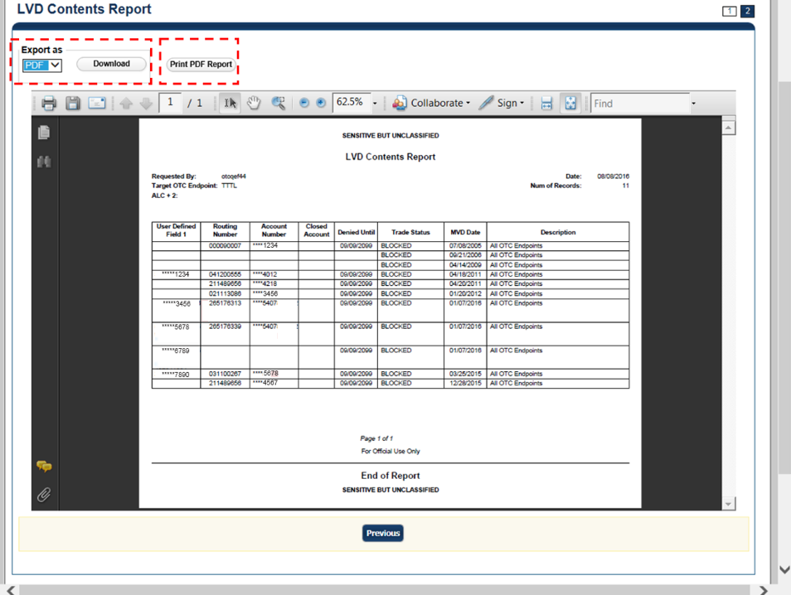

- Under Export as,
- Select a PDF, Excel or Word
- Select Download

Or

Select Print PDF Report
Additional Button
- Select Previous to return to the previous page.

Organization Hierarchy Report
The Organization Hierarchy Report allows you to view the target OTC Endpoint within the context of the current OTC Endpoint. The OTC Endpoints listed in the hierarchy tree are based on the user’s given access permission. Additionally, any endpoint displayed in the hierarchy is designated as a check capture endpoint or is not designated as check capture endpoint but is an endpoint that is associated with at least one check transaction.
To access the report, from Check Processing Reports, Business Reports, select Organization Hierarchy Report.

Organization Hierarchy Report
To view an Organization Hierarchy report, complete the following steps.
- From the Reports tab, select Check Processing Reports. The View Reports page appears.
- Under Business Reports, select Organization Hierarchy Report. The Organization Hierarchy Report parameters page appears.
- Select an OTC Endpoint to initiate the report. The Organization Hierarchy report preview page appears as shown in Figure 8.
Figure 8: Organization Hierarchy Report Preview Page
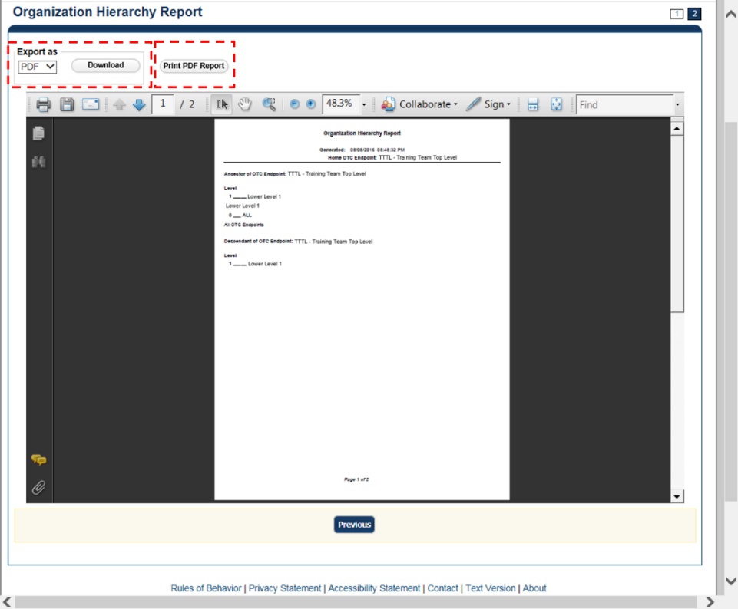
- Under Export as,
- Select a PDF, Excel or Word
- Select Download

Or

- Select Print PDF Report
Additional Button
- Select Previous to return to the previous page.

215 Deposit Ticket Report
The 215 Deposit Ticket Report, also known as the SF215, is a daily report that includes all items deposited and processed into Collections Information Repository (CIR) within the preceding 24 hours. The report is searchable for a duration of up to 45 days. Data for the report is available for a duration of one year.
To access the report, from Check Processing Reports, Business Reports, select 215 Deposit Ticket Report.

215 Deposit Ticket Report
To view a 215 Deposit Ticket report, complete the following steps:
- From the Reports tab, select Check Processing Reports. The View Check Processing Reports page appears.
- Under Business Reports, select 215 Deposit Ticket Report. The 215 Deposit Ticket parameters page appears.
- Enter the search criteria for the report you would like to view.
Under Report Filters,

- Select a From and To Start Date range
- Select Yes to Include Subordinate OTC Endpoint
Application Tips

- The From and To Start Date range is searchable for a duration of up to 45 days. Data for the report is available for a duration of one year.
- Select the Yes option to generate a report that contains data for lower-level OTC Endpoints.

- Under Expand All/Contract All, select the Plus Sign to expand the list of OTC Endpoints and locate the appropriate OTC Endpoint.
Application Tip

CHK denotes a check capture OTC Endpoint; TGA denotes a deposit processing OTC Endpoint; M denotes a mapped accounting code; an open lock denotes access permission; and a closed lock denotes no access permission.

- Select an OTC Endpoint to initiate the report. The 215 Deposit Ticket Report preview page appears as shown in Figure 9.
Figure 9: 215 Deposit Ticket Report Preview Page
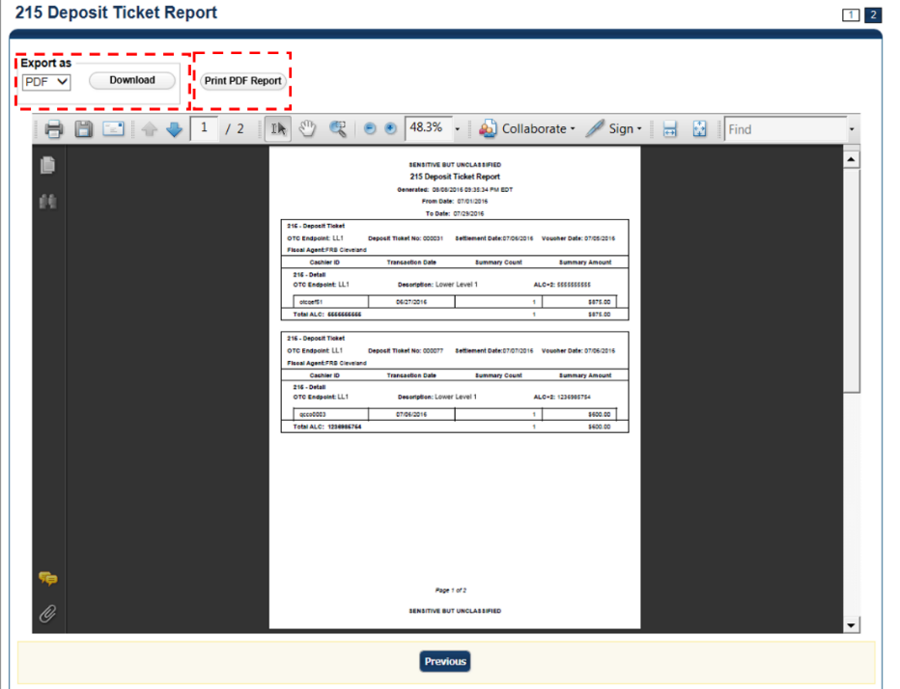
Application Tip

A 215 Deposit Ticket report will not generate for any day that is deemed a holiday during Monday - Friday hours.

- Under Export as,
- Select PDF, Word, or Excel format
- Select Download

Or

- Select Print PDF Report
Additional Button
Select Previous to return to the previous page.

5515 Debit Voucher Report
The 5515 Debit Voucher Report, also known as the SF5515 is a daily report that includes all retired items processed within the preceding 24 hours. The report is searchable for a duration of up to 45 days and will not generate for any day that is deemed a holiday during Monday-Friday hours. Data for the report is available for a duration of one year.
The 5515 report contains the debit voucher number for each item that is retired by the Federal Reserve Bank. The report provides detailed information on the Unique Transaction ID (or IRN number) for easy research in OTCnet.
To access the report, from Check Processing Reports, Business Reports, select 5515 Debit Voucher Report.

5515 Debit Voucher Report
To view a 5515 Debit Voucher report, complete the following steps:
- From the Reports tab, select Deposit Processing Reports. The View Reports page appears.
- Under Business Reports, select 5515 Debit Voucher Report. The 5515 Debit Voucher parameters page appears.
- Enter the search for the report you would like to view.
Under Report Filters,
- Select a From and To Start Date range
- Select Yes or No to Include Subordinate OTC Endpoints.
Application Tips

- The From and To Start Date range is searchable for a duration of up to 45 days. Data for the report is available for a duration of one year.
- Select the Yes option to generate a report that contains data for the selected OTC Endpoint as well as all of the lower-level OTC Endpoints. Select the No option to generate a report that contains data only for the selected OTC Endpoint.
- CHK denotes a check capture OTC Endpoint; TGA denotes a deposit processing OTC Endpoint; M denotes a mapped accounting code; an open lock denotes access permission; and a closed lock denotes no access permission.

- Select an OTC Endpoint to initiate the report. The 5515 Debit Voucher preview page appears as shown in Figure 10.
Figure 10: 5515 Debit Voucher Report Preview Page
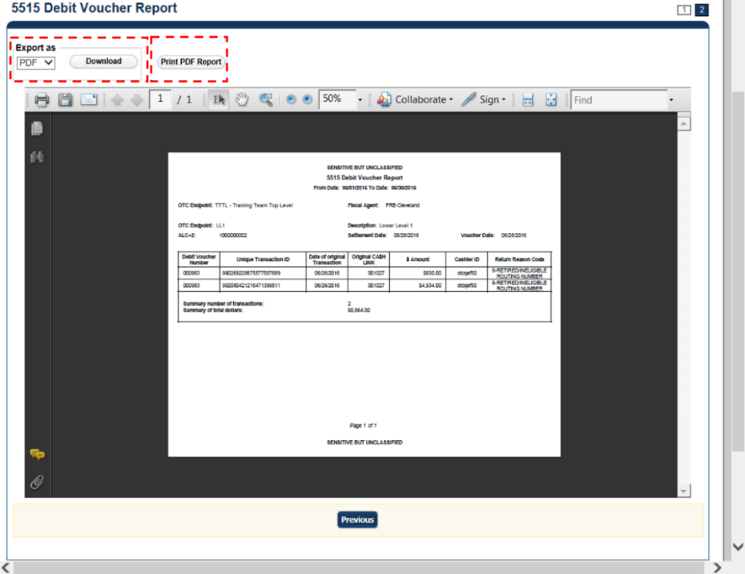
Application Tip

A 5515 Debit Voucher report will not generate for any day that is deemed a holiday during Monday-Friday hours.

- Under Export as,
- Select PDF, Excel or Word format
- Select Download

Or

- Select Print PDF Report
Additional Button
- Select Previous to return to the previous page.

ACR Activity Report
The ACR Activity Report, or Adjustment, Correction and Rescission Report, is a report that displays the detailed information about transactions that were adjusted, corrected, or reversed/rescinded. Users can generate a report that covers a maximum period of 45 calendar days.
To access the report, from Check Processing Reports, Business Reports, select ACR Activity Report.

ACR Activity Report
To search for ACR transactions, complete the following steps:
- From the Reports tab, select Check Processing Reports and select ACR Activity Report. The ACR Activity Report page appears.
- Enter the search criteria you would like to view.
- Enter the From and To ACR Settlement date range
- Select a Report Type
- Select an ACR Type
- Select an ACR Reason Code
Application Tips

- The maximum date range for the From and To ACR (Adjustment, Correction, and Rescission) Settlement range is 45 days.
- Report Type options include Credit/Debit - ACR, Credit - ACR, and
Debit - ACR.
- Search ACR Transaction options include All ACR, Adjustment, Correction, and Rescission.
- ACR Reason Code options include Duplicate Transaction Processed, Non-Cash Item, Transaction Amount Correction, Representment, Warranty Indemnity Claim, Voucher Date Change, Voucher Number Change, Account Switch, Transaction Account Switch, and ACH Reversal.

- Select the Yes or No radio button to Include Subordinates
- Select an OTC Endpoint to initiate the report. The ACR Activity Report preview page appears as shown in Figure 11.
Figure 11: ACR Activity Report Preview Page
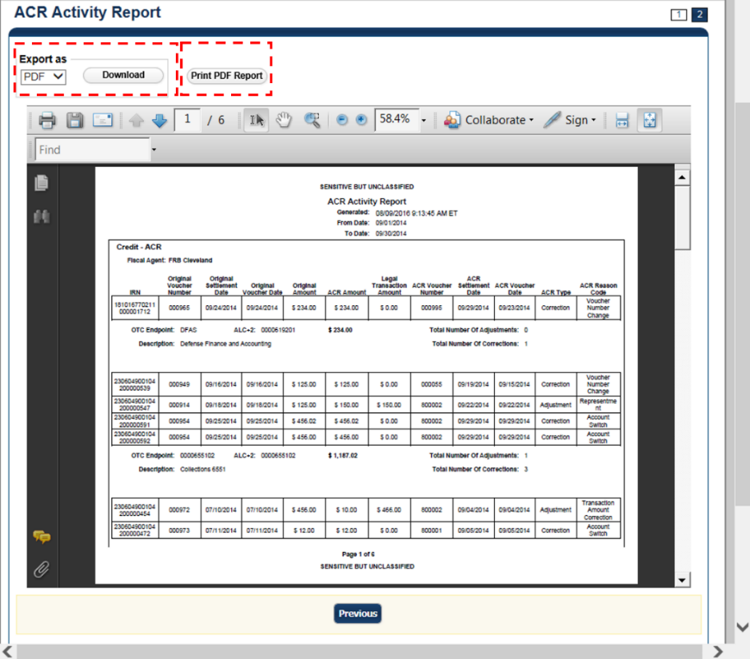

- Under Export as,
- Select a PDF, Excel or Word
- Select Download

Or

- Select Print PDF Report
Additional Button
- Select Previous to return to the previous page.

Topic 4 Administration Reports
There are three Administration reports that you may have access to, depending on your role. As an FMS Viewer, you are authorized to access the CIRA Transmission Summary, CIRA Transmission (Detailed) Summary, and View CIR Transmission Status for Check Processing Administration reports (see Table 3 for details). To print a report output, right select using your mouse and select Print.
Table 3: Administration Reports (1st column) and Access Type (1st row)
Business Reports | Agency Manager | Check Capture Administrator | MVD Viewer | MVD  Editor | FMS  Viewer | View  Reports
CIRA Transmission Summary Report | blank | blank | blank | blank | X | blank
CIRA Transmission (Detailed) Summary Report | blank | blank | blank | blank | X | blank
View CIR Transmission Status for Check Processing | blank | blank | blank | blank | X | blank
Legend: Blank = N/A & X = Access

CIRA Transmission Summary Report
The CIRA Transmission Summary Report allows you to view a list of transactions sent to Debit Gateway. To access the report, from Check Processing Reports, Administration, select CIRA Transmission Summary Report.

View CIRA Transmission Summary Report
To view a CIRA Transmission Summary report, complete the following steps:
- From the Reports tab, select Check Processing Reports. The View Check Processing Reports page appears.
- Under Administration Reports, select CIRA Transmission Summary Report. The CIRA Transmission Summary Report page appears.
- Enter the search criteria for the report you would like to view.
Under Report Filters, complete the following:
- Select a Date
- Select Submit Request. The Transmission Files table for the selected date appears.
- Select Yes or No to Include Subordinate OTC Endpoints
Application Tips

- The Transmission Files table lists all the transmissions for the selected date.
- Select the Yes option to generate a report that contains data for the selected OTC Endpoint as well as all of the lower-level OTC Endpoints.
Select the No option to generate a report that contains data only for the selected OTC Endpoint
- CHK denotes a check capture OTC Endpoint; TGA denotes a deposit processing OTC Endpoint; M denotes a mapped accounting code; an open lock denotes access permission; and a closed lock denotes no access permission.

- Select an OTC Endpoint to initiate the report. The CIRA Transmission Summary Report preview page appears as shown in Figure 12.
Figure 12: CIRA Transmission Summary Report Preview Page
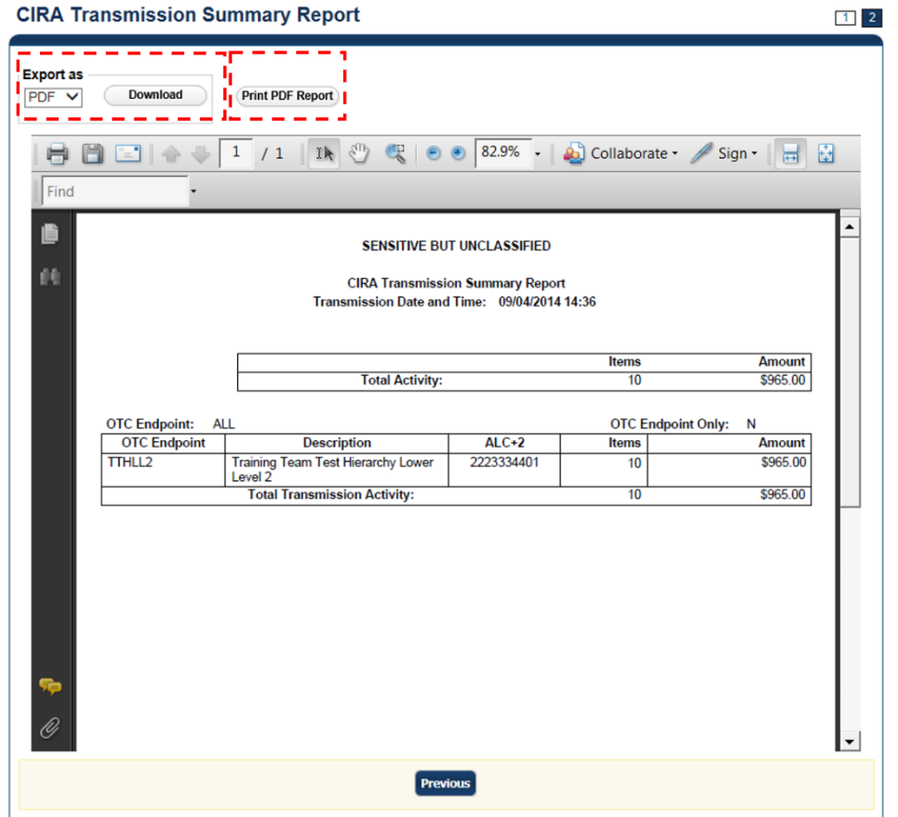

- Under Export as,
- Select a PDF, Excel or Word
- Select Download

Or

- Select Print PDF Report
Additional Button
- Select Previous to return to the previous page.

CIRA Transmission (Detailed) Summary Report
The CIRA Transmission (Detailed) Summary Report allows you to view the detailed information about transactions sent to Debit Gateway. To access it, from Check Processing Reports, Administration Reports, select CIRA Transmission (Detailed) Summary Report.

CIRA Transmission Summary Report
To view a CIRA Transmission (Detailed) Summary report, complete the following steps:
- From the Reports tab, select Check Processing Reports. The View Check Processing Reports page appears.
- Under Administration Reports, select CIRA Transmission (Detailed) Summary Report. The CIRA Transmission (Detailed) Summary Report parameters page appears.
- Enter the search criteria for the report you would like to view.
Under Report Filters,
- Select a Date
- Select Submit Request. The Transmission Files table for the selected date appears.
- Select Yes or No to Include Subordinate OTC Endpoints
Application Tips

- The Transmission Files table lists all the transmissions for the selected date.
- Select the Yes option to generate a report that contains data for
the selected OTC Endpoint as well as all of the lower-level OTC Endpoints.
Select the No option to generate a report that contains data only for the selected OTC Endpoint.
- CHK denotes a check capture OTC Endpoint; TGA denotes a deposit processing OTC Endpoint; M denotes a mapped accounting code; an open lock denotes access permission; and a closed lock denotes no access permission.

- Select an OTC Endpoint to initiate the report. The CIRA Transmission (Detailed) Summary Report preview page appears as shown in Figure 13.
Figure 13: CIRA Transmission (Detailed) Summary Report
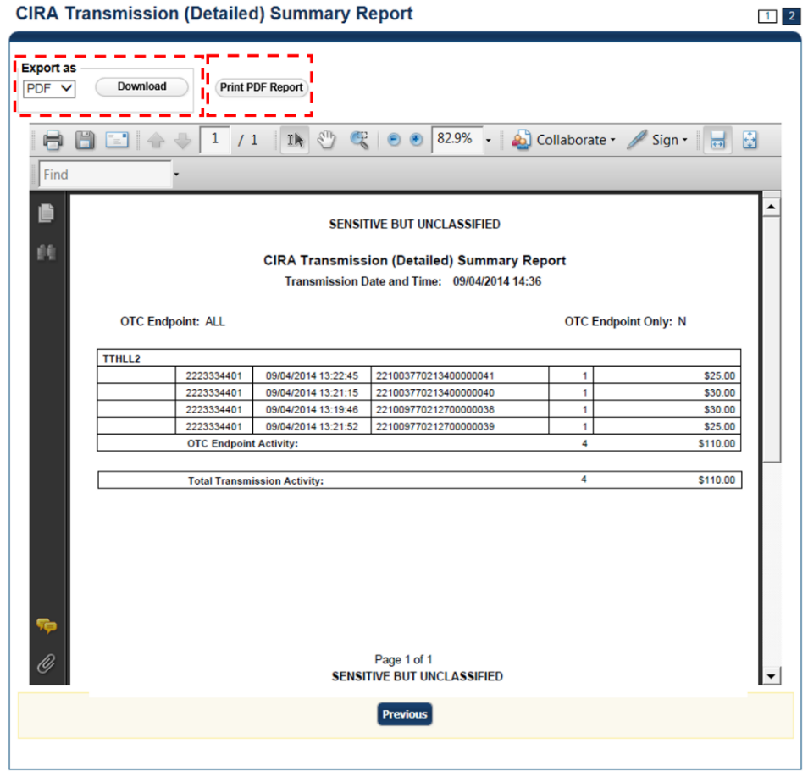
- Under Export as,
- Select a PDF, Excel or Word
- Select Download

Or

- Select Print PDF Report
Additional Button
Select Previous to return to the previous page.

View CIR Transmission Status for Check Processing
The View CIR Transmission Status for Check Processing report allows you to view the status of CIR files that have been processed by CIR or are ready for CIR processing. The View CIR Transmission Status for Check Processing page is divided into two sections: Top section displays the check transmissions that have not been successfully processed by CIR. The bottom section displays all the check transmissions that have been sent to CIR regardless of their status.
To access the report, from Check Processing Reports, Administration Reports, select View CIR Transmission Status for Check Processing.

View CIR Transmission Status for Check Processing
To generate a View CIR Transmission Status for a Check Processing report, complete the following steps:
- From the Reports tab, select Check Processing Reports. The View Reports page appears.
- Under Administration Reports, select View CIR Transmission Status for Check Processing. The View CIR Transmission Status for Check Processing parameters page appears.
- Select the Transmission ID to view the CIR transmission details or processing errors.
- The CIR Transmission Status Export/Print Report preview page appears as shown in Figure 14.
Figure 14: CIR Transmission Status Export/Print Report Page
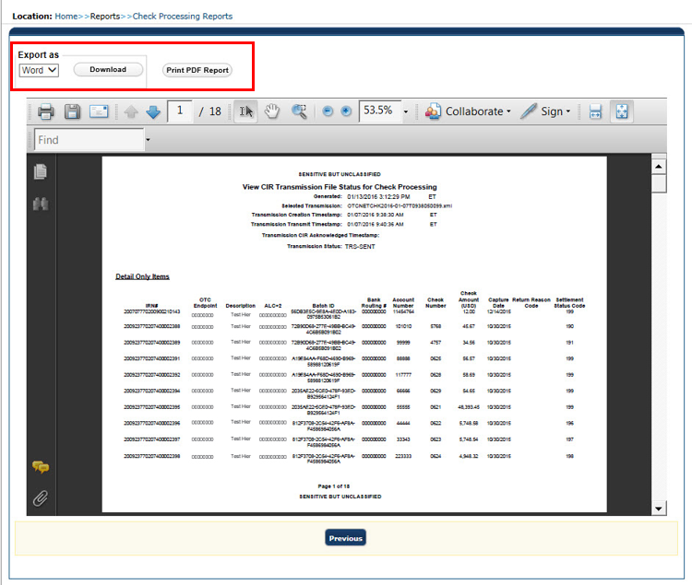
Under Export as,
- Select a PDF, Excel or Word
- Select Download

Or

- Select Print PDF Report
Additional Button
Select Previous to return to the previous page.

Topic 5 Scheduled Reports
Scheduled Reports are asynchronous reports that you can request in advance and review later. They include historical reports older than 18 months for check processing and 5 years for deposit processing.
Check Processing Historical Reports are used to query check records that are associated with batches that have a Received Date older than 18 months. All batches including batches with an Open or Closed status with a Received Date older than 18 months are saved in the Historical database.
Here are some items to keep in mind for Scheduled Reports:
- Check Transactions with a received date older than the minimum data retention period, as specified by Fiscal Service, may not be displayed on the report as these transactions are eligible to be deleted. As a result, this queried check information may not be accessible and will be removed from the archival database.
- They are generated asynchronously (not occurring at the same time), allowing you to continue to use OTCnet.
- Depending on the volume of data requested, it can take between five to 20 minutes for the report to generate. As an Agency Manager, Check Capture Administrator, MVD Editor, MVD Viewer, or FMS Viewer, you are authorized to query and download CIRA CSV Historical reports.
- You can search for check records by OTC Endpoint, User Defined Fields, Account Number, Bank Routing Number, Individual Reference Number (IRN), and other search criteria. Running a search without specifying any criteria other than an OTC Endpoint, will result in a search that includes all checks in the system that you have access to view.
- When the report request is submitted, its status is set to Submitted. After the report is successfully generated, the status is set to Completed and the report is available for download in CSV format.
- Previously generated reports are available for seven days and can be downloaded using the View Previously Generated Reports function. Duplicate report requests based on identical search parameters cannot be made within the same 7-day period; however, after 7 days the same report request can be submitted.
- OTCnet does not limit the number of rows that can be downloaded in a CIRA CSV Historical report. However, for Microsoft Excel 2010 or higher, you are authorized to view all records returned in a CIRA CSV Historical file up to approximately 1 million rows. For Microsoft Excel 2003, to generate a CIRA CSV Historical report, any rows after 65,000 rows will not be displayed because Microsoft Excel 2003 has a 65,000-row limit.

CIRA CSV Historical Report
The CIRA CSV Historical Report allows you to review past exported data based on a query to a Comma Separated Value (CSV) report. To access the report, from Scheduled Reports, select Generate Scheduled Reports, Check Processing Historical Reports, select CIRA CSV Historical Report.
When selecting the Received Date radio button, consider the following information for the Received Date (From) and (To):
- If the Received Date radio button is selected, OTCnet does not validate any other date range values (Capture Date, Settlement Date or Return Settlement Date).
- Received Date (From) and (To) represents the date range the check was received into OTCnet. Received Date (On) represents the single specific date the check was received into OTCnet.
- The Received Date (From) and (To) fields are searchable for a duration up to 31 days.
- The Received Date (From) and (To) dates must be older than 18 months from the current date.
When selecting the Check Capture Date radio button, consider the following information for the Check Capture (From) and (To):
- If the Check Capture Date radio button is selected, OTCnet does not validate any other date range values (Received Date, Settlement Date, or Return Settlement Date).
- Check Capture Date (From) and (To) represents the date range the check was processed by the Check Capture Lead Operator or Check Capture Operator. Check Capture Date (On) represents the single specific end date the check was processed by the Check Capture Lead Operator or Check Capture Operator.
- The Check Capture Date (From) and (To) fields are searchable for a duration up to 31 days.
- The Check Capture Date (From) and (To) dates must be older than 18 months from the current date.
When selecting the Settlement Date radio button, consider the following information for the Settlement (From) and (To):
- If the Settlement Date radio button is selected, OTCnet does not validate any other date range values (Received Date, Capture Date or Settlement Date).
- If the Settlement Date radio button is selected, OTCnet does not validate any other date range values (Received Date, Capture Date or Settlement Date).
- Settlement Date (From) and (To) represents the date range when the check item was returned. Settlement Date (On) represents the single specific date the check item was returned.
- The Settlement Date (From) and (To) fields are searchable for a duration up to 31 days.
- The Settlement Date (From) and (To) dates must be older than 18 months from the current date.
When selecting the Return Settlement Date radio button, consider the following information for the Return Settlement (From) and (To):
- If the Return Settlement Date radio button is selected, OTCnet does not validate any other date range values (Received Date, Capture Date or Settlement Date).
- Return Settlement Date (From) and (To) represents the date range when the check item was returned. Return Settlement Date (On) represents the single specific date the check item was returned.
- The Return Settlement Date (From) and (To) fields are searchable for a duration up to 31 days.
- The Return Settlement Date (From) and (To) dates must be older than 18 months from the current date.

CIRA CSV Historical Report
To view a CIRA CSV Historical report, complete the following steps:
- From the Reports tab, select Scheduled Reports.
- Select Generate Scheduled Reports.
- Under Check Processing Historical Reports, select CIRA CSV Historical Report. The CIRA CSV Historical Report page appears.
Application Tip

The CIRA CSV Historical Report is generated asynchronously (not occurring at the same time) allowing you to continue using the OTCnet application. Depending on the volume of data queried it can take between 5 and 20 minutes to generate the report.

- Enter the search criteria for the report you would like to view.
- Select an OTC Endpoint, required
- Check/uncheck the Include Subordinates check box
Application Tips

- If you do not know the full name of the OTC Endpoint, enter a partial name search (as few as one letter) in the Starts with text box and select the Select From List icon (magnifying glass). The configured OTC Endpoints appear according to the user’s access. Select the appropriate OTC Endpoint radio button.
- By default, the Include Subordinates check box is checked. Add a check mark to generate a report that contains data for the subordinate OTC Endpoints. Remove the check mark to generate a report that contains data only for the selected OTC Endpoint.

- To search for a transaction:
  - Using the CIRA CSV Historical Report search criteria, complete the following steps:
Under CIRA CSV Historical Report,
- Select a Form Name
- Select a Deploy Date
Application Tips

- By default, the CIRA CSV Historical Report screen is expanded. If the CIRA CSV Historical Report - ACR screen is expanded, the CIRA CSV Historical Report screen is collapsed.
- The Form Name is the name/list of available forms available for the selected OTC Endpoint. The Deploy Date is the date, time and version number of the selected form.
- By default, the most recent Deploy Date and Form Version will populate the Deploy Date field, once the Form Name is selected.

Under User Defined Fields,
- Enter User Defined Field 1
- Enter User Defined Field 2
- Enter User Defined Field 3
- Enter User Defined Field 4
- Enter the Account number
- Enter the Bank Routing Number
- Enter the IRN (Individual Record Number)
- Enter the Check Number
Application Tips

- The User Defined Fields are visible based on the selected OTC Endpoint Form Name and Deploy Date.
- If an IRN and a date range (Received Date, Capture Date, Settlement Date, and Return Settlement Date) are entered, OTCnet ignores the date range during report generation.

Under Check Amount,
- Select the appropriate drop-down field
- Enter the check amount
- Select a Settlement Status
- Enter the 5515/Debit Voucher Number
- Enter the 215/Deposit Ticket Number
- Enter the Cashier ID
- Enter the Batch ID
Application Tips

- The 5515/Debit Voucher Number represents items returned to agency due to unsuccessful collection efforts.
- The 2515/Deposit Ticket Number represents items credited into FRB CA$HLINK for a given agency on a given day.
- If a Batch ID and a date range (Received Date, Capture Date, Settlement Date, and Return Settlement Date) are entered, OTCnet ignores the date range during report generation.

Select the Received Date: radio button
- Select From and To Received Date range
Or
- Select the On Received Date

Or

Select the Check Capture Date: radio button
- Select From and To Check Capture Date range
Or
- Select the On Check Capture Date

Or

Select the Settlement Date: radio button
- Select From and To Settlement Date range
Or
- Select the On Settlement Date

Or

Select the Return Settlement Date: radio button
- Select the From/On Date range
- Select the To Date range
Or

  - To query for an ACR transaction, complete the following steps:
- Select CIRA CSV Historical Report - ACR to expand the screen
- Select an ACR Type
- Select an ACR Reason Code
- Enter an ACR Voucher Number
- Enter the From and To ACR Settlement Range, Required
Application Tips

- By default, the CIRA CSV Historical Report - ACR (Adjustment, Correction, and Rescission) screen is collapsed. If the Search ACR Transaction screen is expanded, the CIRA CSV Historical Report screen is collapsed.
- Search ACR Transaction options include All ACR, Adjustment, Correction, and Rescission.
- ACR Reason Code options include Duplicate Transaction Processed, Non-Cash Item, Transaction Amount Correction, Representment, Warranty Indemnity Claim, Voucher Date Change, Voucher Number Change, Account Switch, and ACH Reversal.
- The maximum numeric characters value for ACR Voucher Number is six.
- The From and To ACR Settlement fields are searchable for a duration up to 90 days. Additionally, the From and To ACR Settlement dates must be older than 18 months from the current date.

- Select Submit Request. A “Your report request has been successfully received” message appears as shown in Figure 15.
Figure 15: CIRA CSV- Request Successfully Submitted
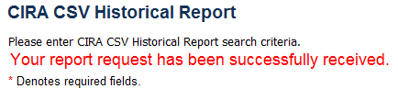
Additional Buttons
- Select Cancel to return to the OTCnet Home Page. No data will be saved.
- Select Clear to clear all data fields and reset to the default selections.

Previously Generated Reports
Previously Generated reports are used to query records associated with batches that have a Received Date older than 18 months. Access these reports from Scheduled Reports and select View Previously Generated Reports.
Consider the following information when generating a Scheduled Report:
- When a report request is submitted, its status is Submitted.
- When a report is successfully generated, the status is Completed and available for download.
- When a report request is submitted and the Historical database is unavailable, an informational message appears stating, “Historical database is currently unavailable. All reports in Submitted status will be processed when the Historical database is available.” Report requests that are in Submitted status will remain in Submitted status until the database is available and the report is generated. After the report is generated, a Completed status is displayed.
- When a report request is submitted and the report could not generate (e.g., code error), its status is Error. Resubmit your report request to ensure your report is generated. If a report displays an Error status, the request can be resubmitted at any time without receiving a duplicate request message.

View Previously Generated Reports
To view previously generated reports, complete the following steps:
- From the Reports tab, select Scheduled Reports and select View Previously Generated Reports. The View Previously Generated Reports page appears as shown in Figure 16.
Figure 16: View Previously Generated Reports
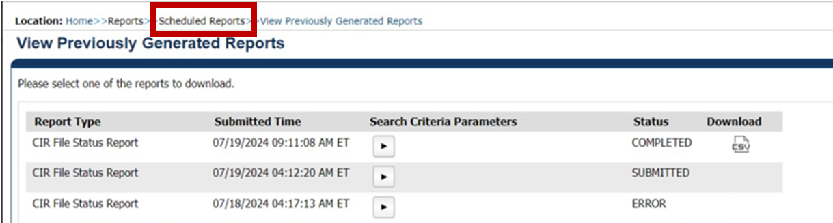
- Select the CSV icon in the Download column to view your desired report. The report opens as a csv file.
Application Tips

- Once the CSV file is downloaded, it can be opened using Excel or Notepad.
- Previously generated reports are available for 30 days. Duplicate report requests based on identical report parameters cannot be made within the same 7-day period; however, after 7 days a duplicate report request can be submitted. Report requests are user specific and are not viewable by other users.
- The CIRA CSV Historical Report page is configured to download a maximum of 31 days of search results. This range parameter applies when a user searches using Received Date, Check Capture Date, Settlement Date or Return Settlement Date. The system will display an error message to you when searching for results beyond the configured range.

- Select Open, Save, or Cancel.
Additional Button
- Select Open and the file content displays.
- Select Save and choose the location for saving the file.
- Select Cancel and the dialog box closes. No data is saved.
- Select Cancel again to return to the OTCnet Home Page. No data is saved.

Summary
In this chapter, you learned:
- The purpose of accessing check processing reports
- How to view a CIRA Query
- How to view and download a CIRA CSV Report
- How to view and print a Check Image Report
- How to view and print an Agency CIRA Report
- How to view and print an LVD Contents Report
- How to view and print an Organizational Hierarchy Report
- How to view and print a 215 Deposit Ticket Report
- How to view and print a 5515 Debit Voucher Report
- How to view and print an ACR Activity Report
- How to view and print a CIRA Transmission Summary Report
- How to view and print a CIRA Transmission (Detailed) Summary Report
- How to view and download Scheduled Reports

